

**Web Engineering (Theory part)**

**TITLE: ResearchArchive.com**

**Submitted by:**

**Name:** Md. Sami Alam

**ID:** 222-16-656

**Section:** 15_16 A

**Subject Code:** CIS 331

**Course Title:** **Web Engineering**

**Semester:** Fall 2024

**Department** Of **CIS**, **DIU**

**Due Date:** 4th December, 2024

**Submitted to:**

**Name:** Ms. Sonia Nasrin

**Designation:** Lecturer

**Department:** Computing and Information System, DIU

Submission date 4th December, 2024

**Introduction**

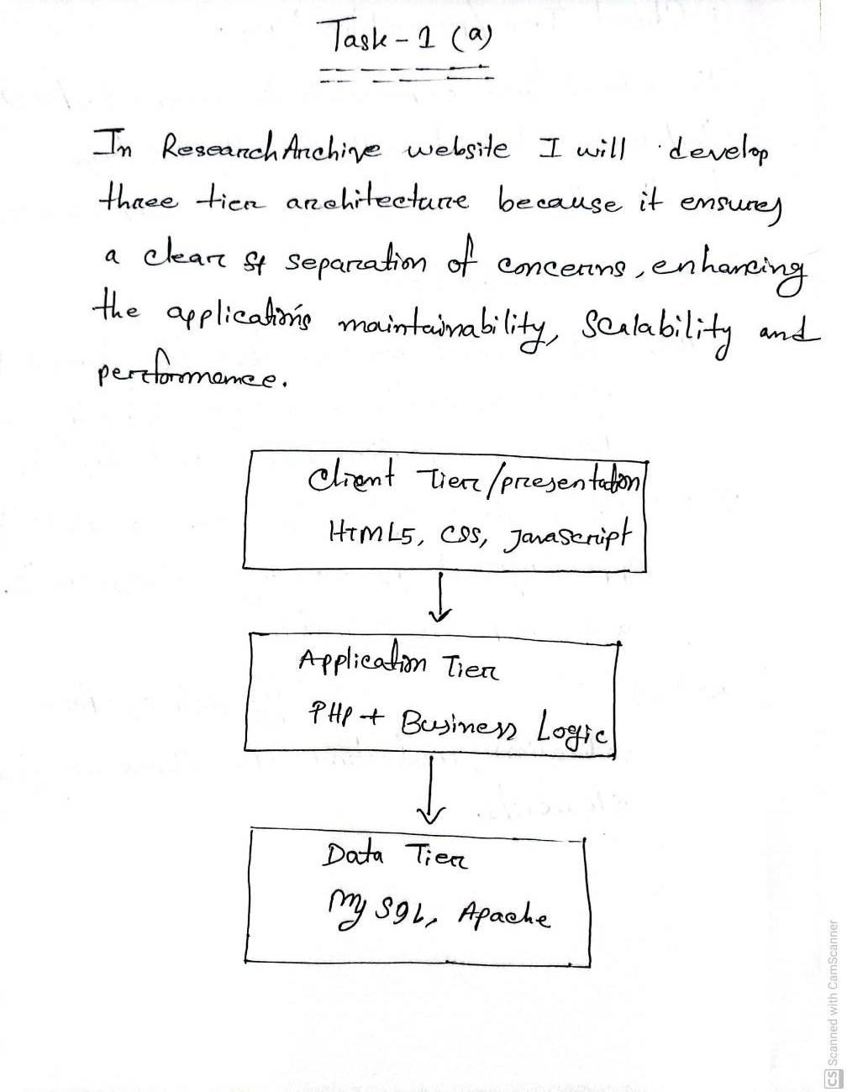

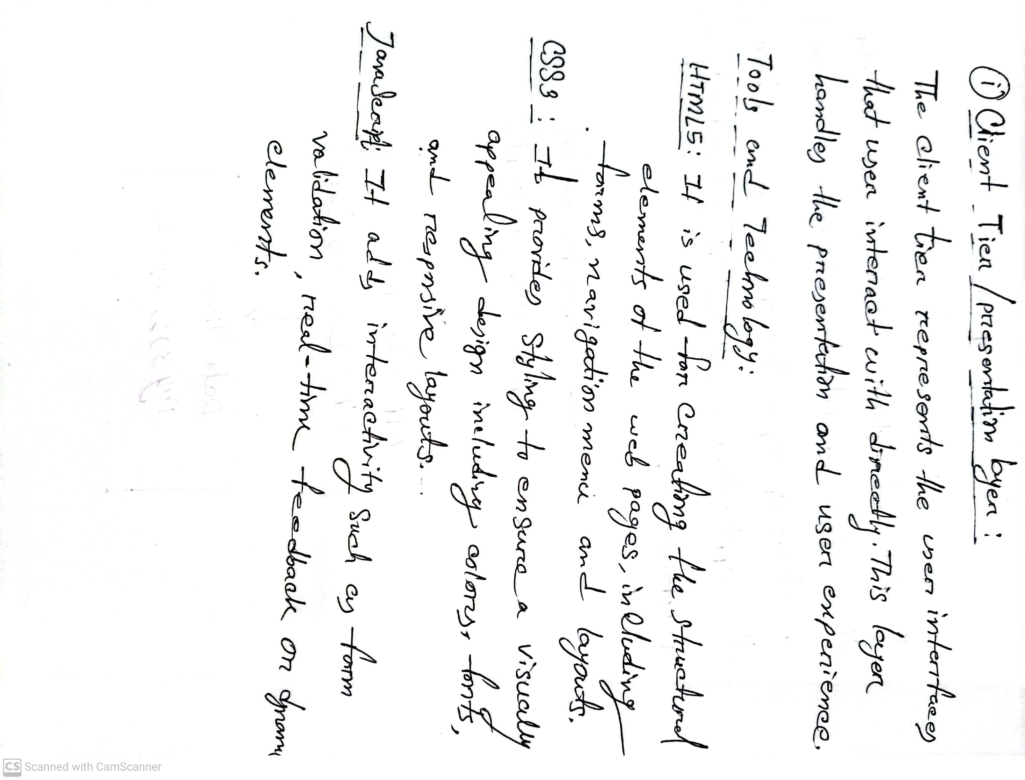 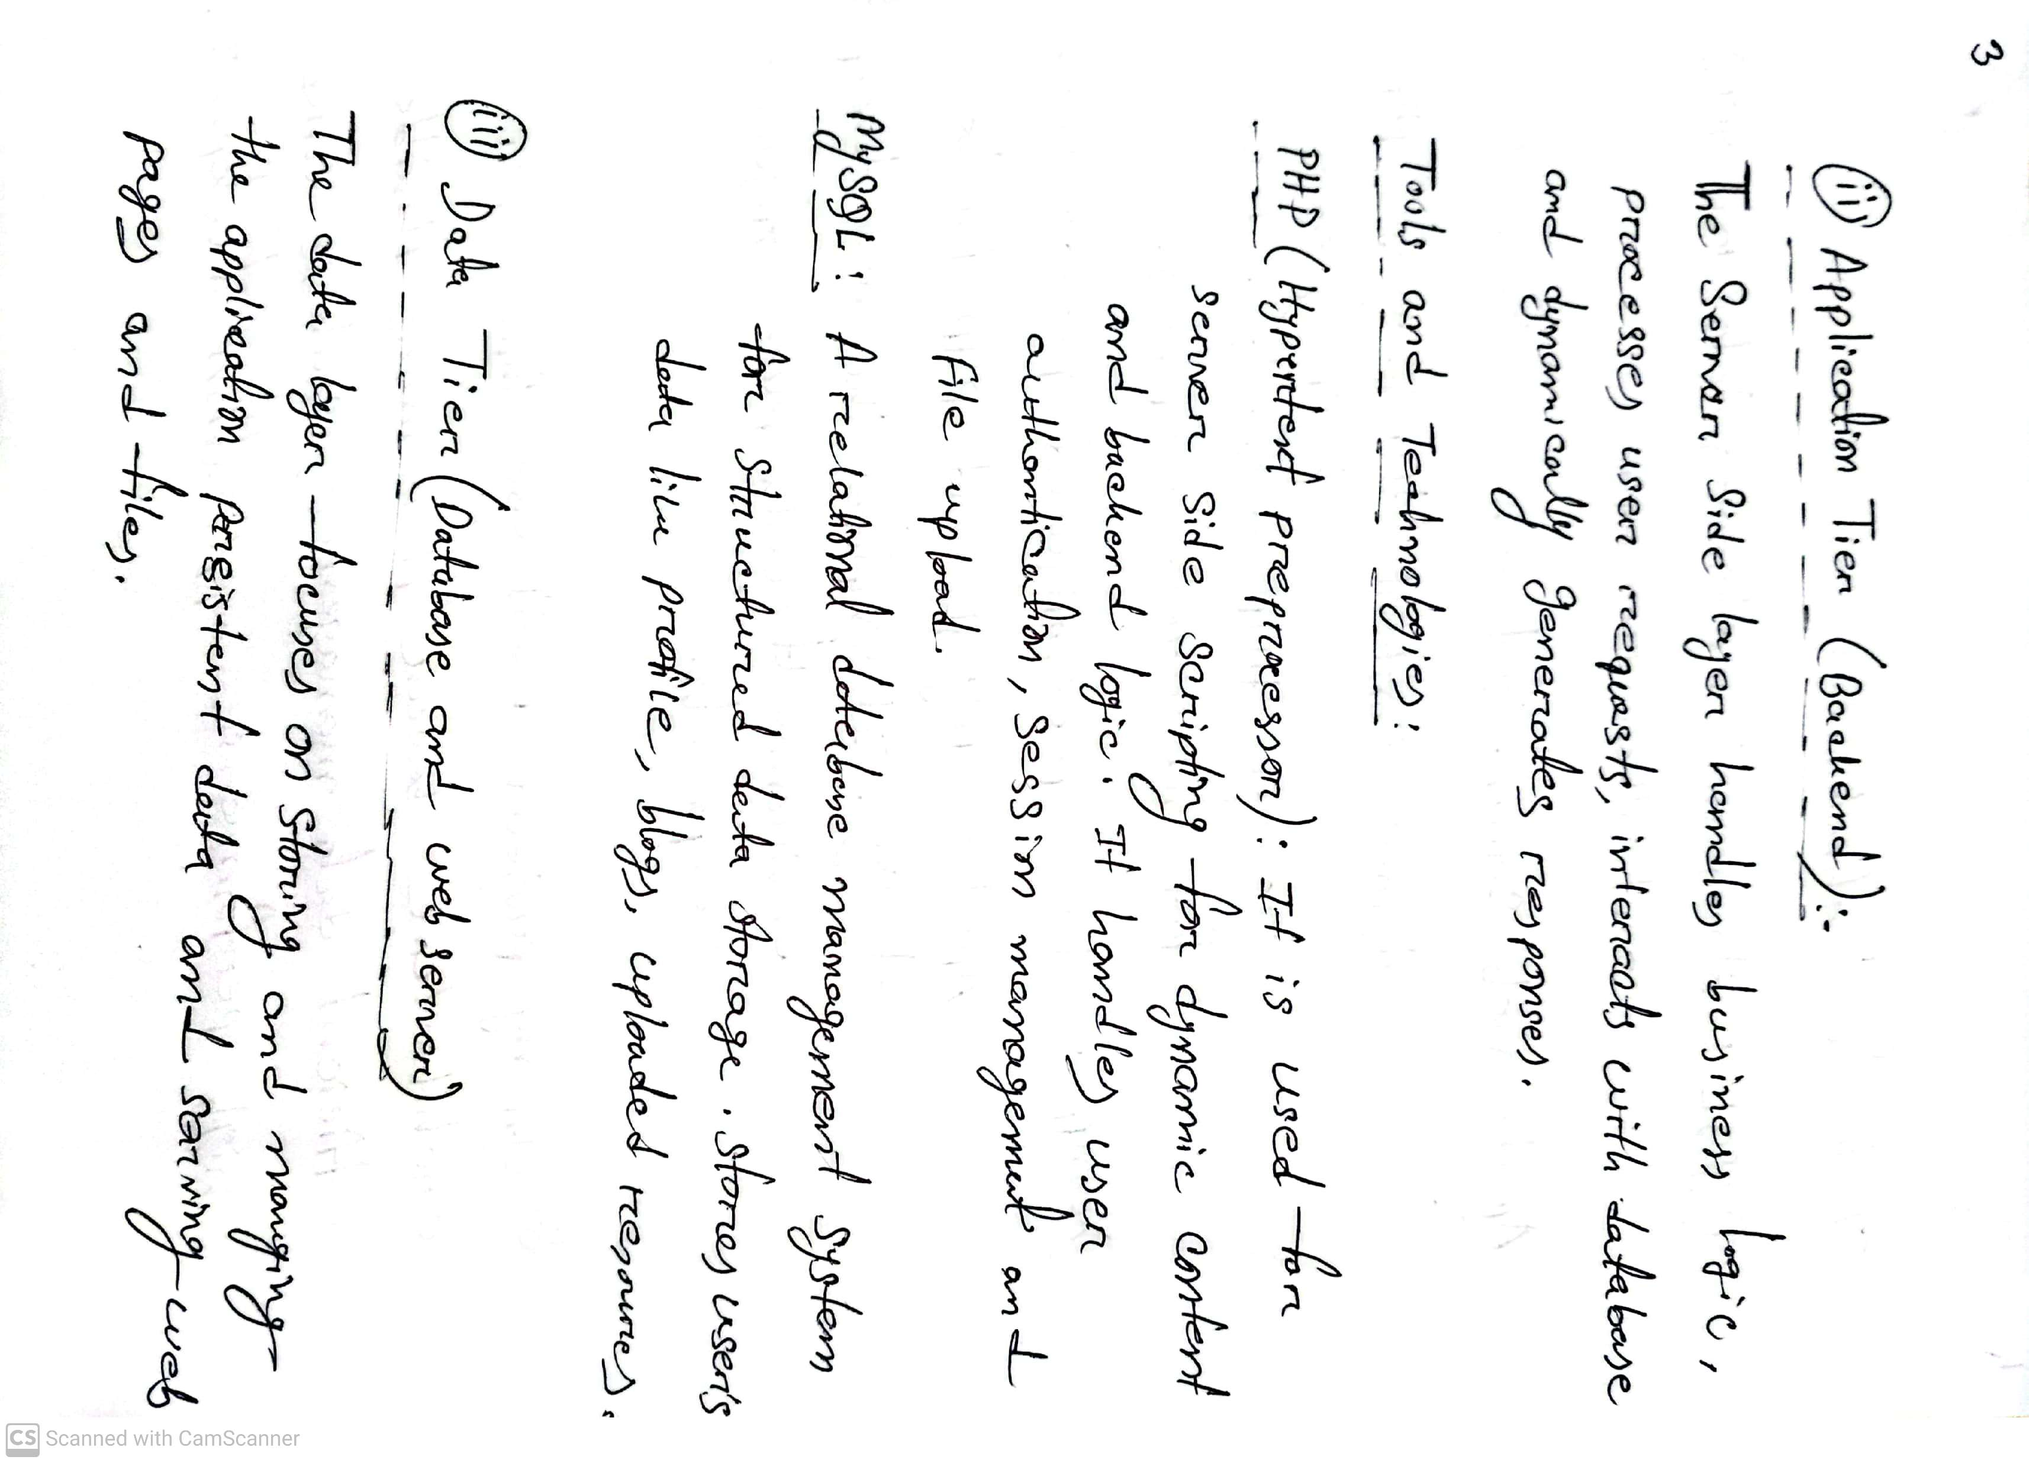 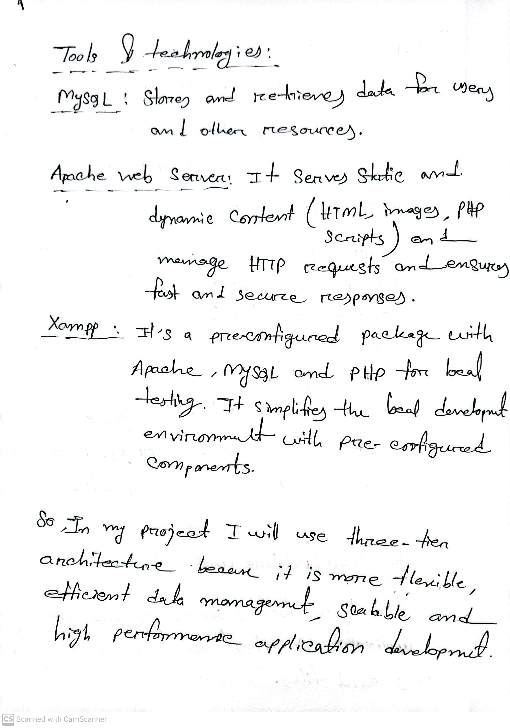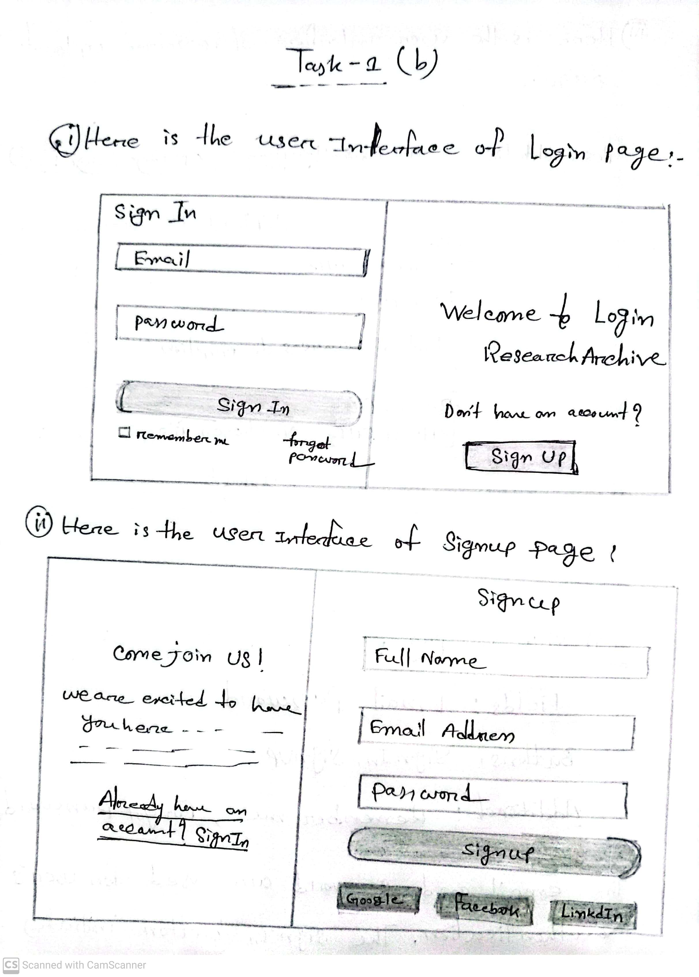 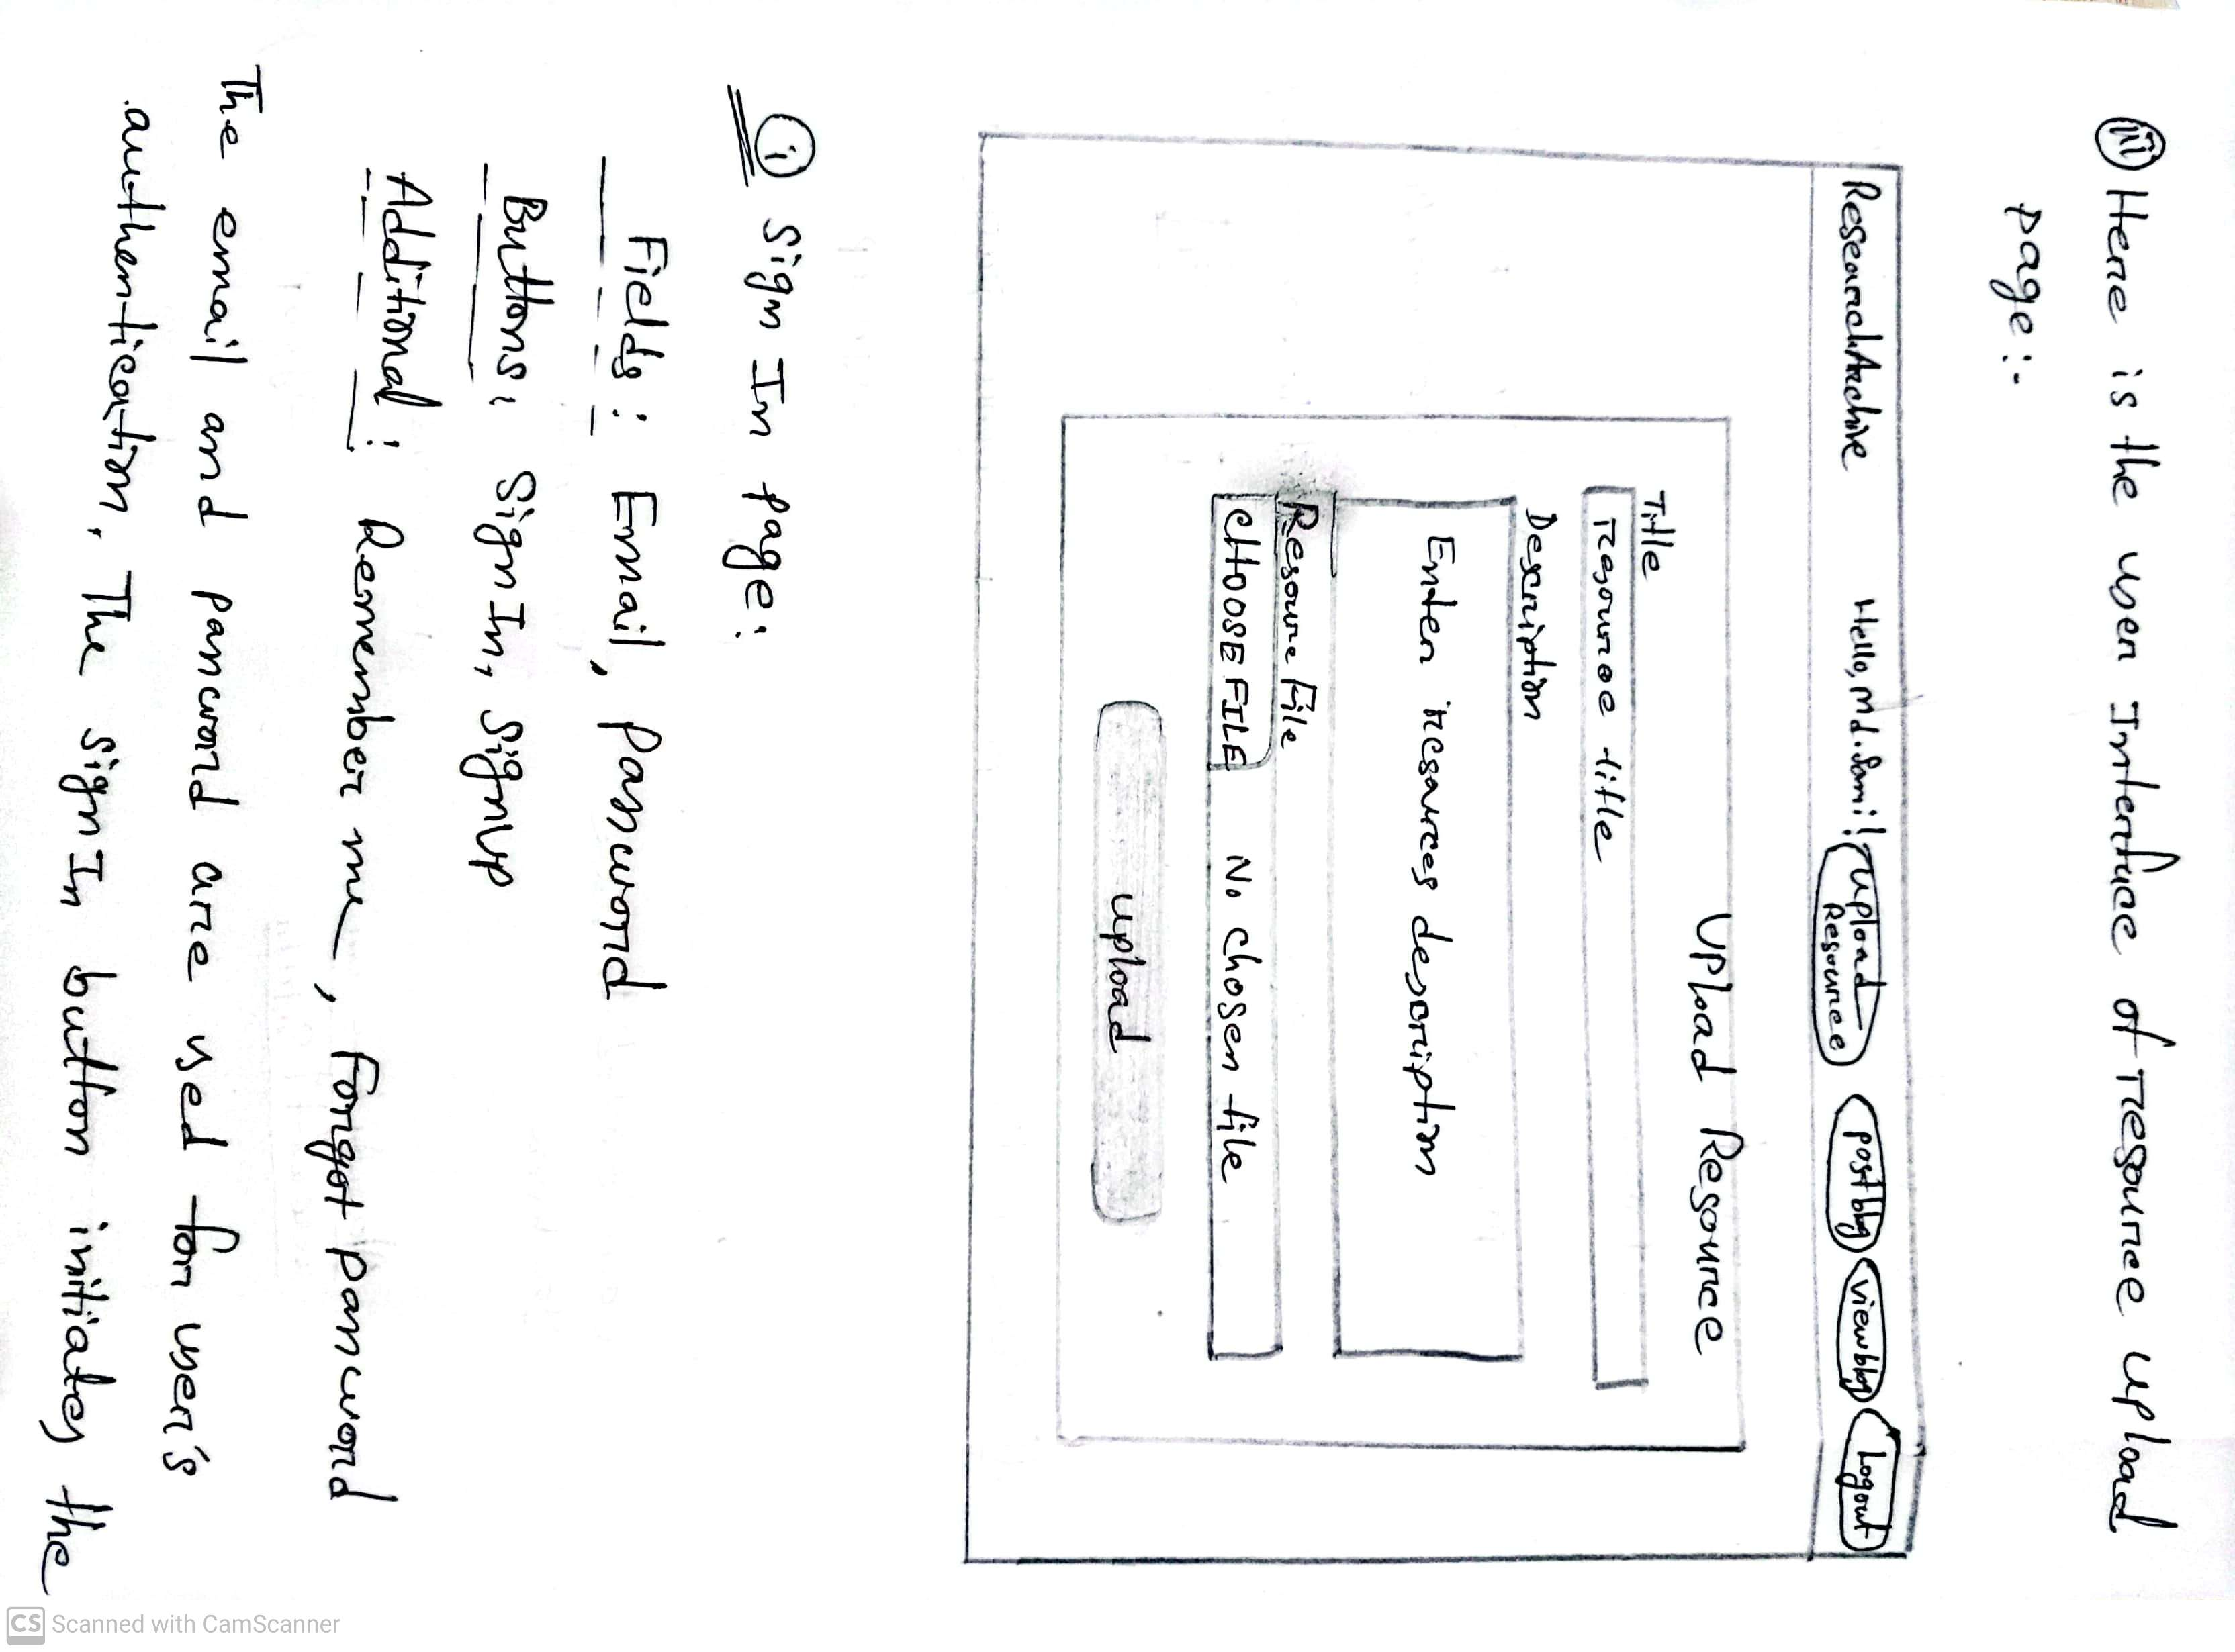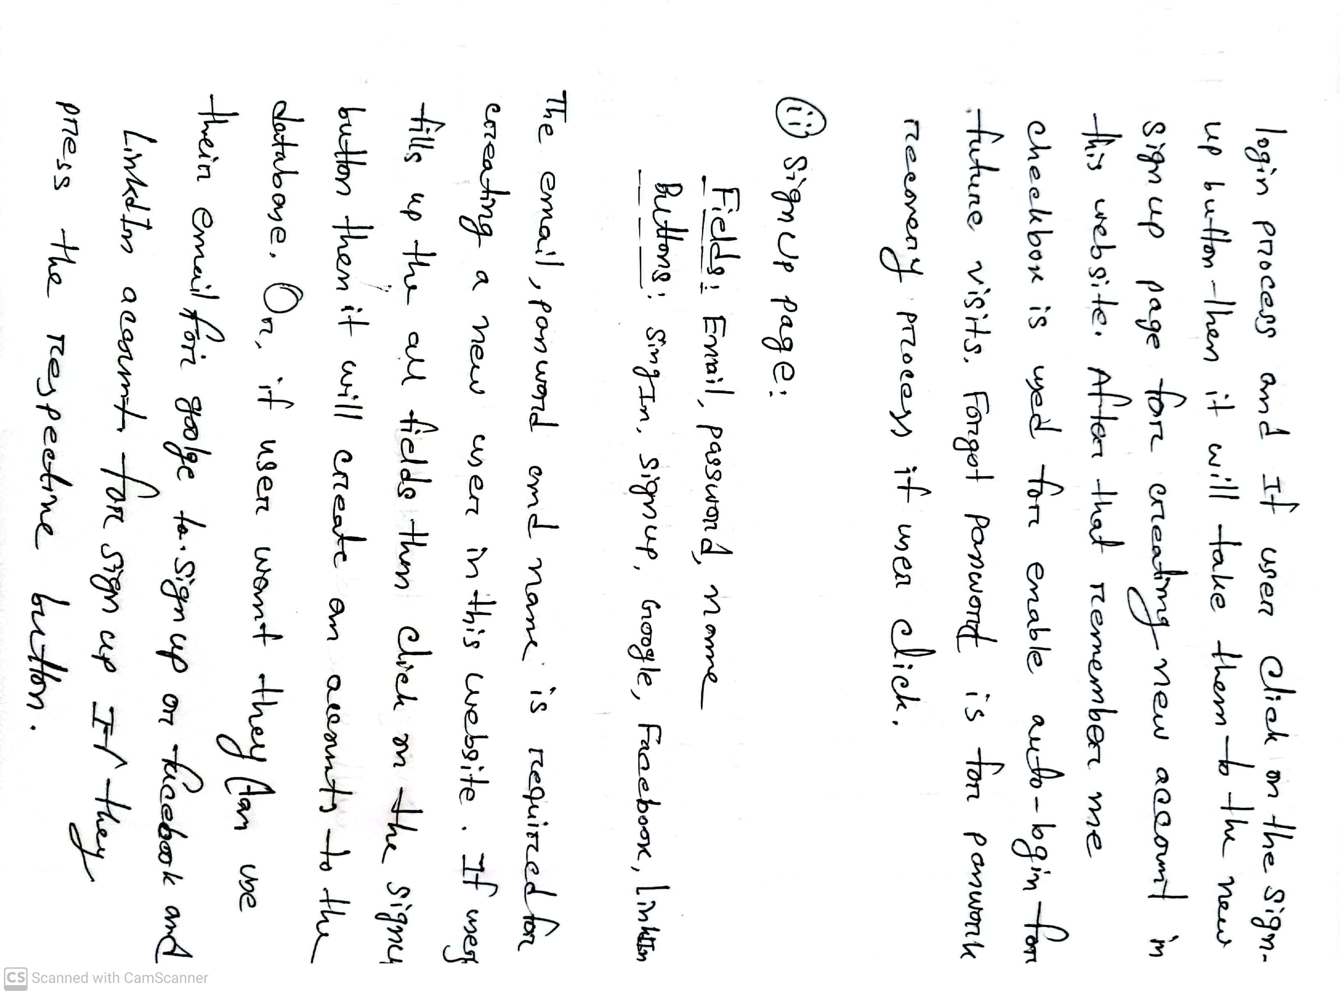

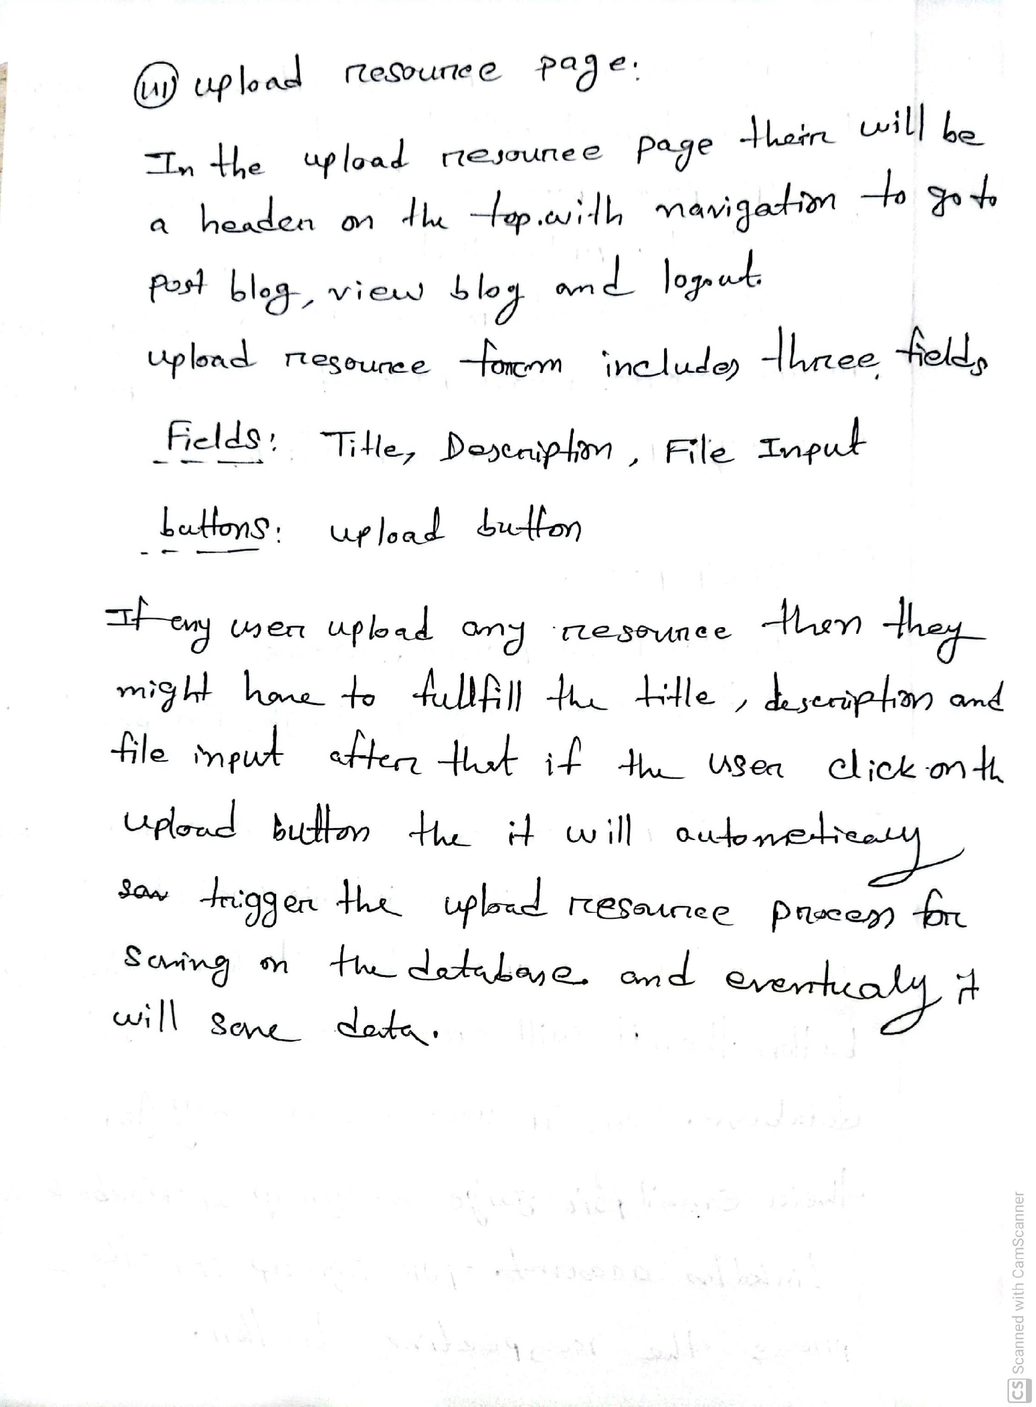

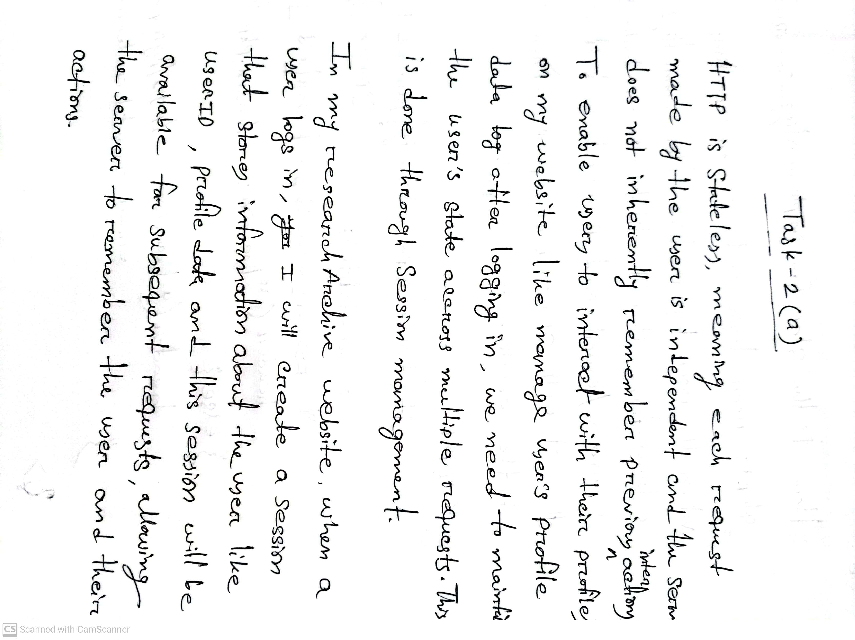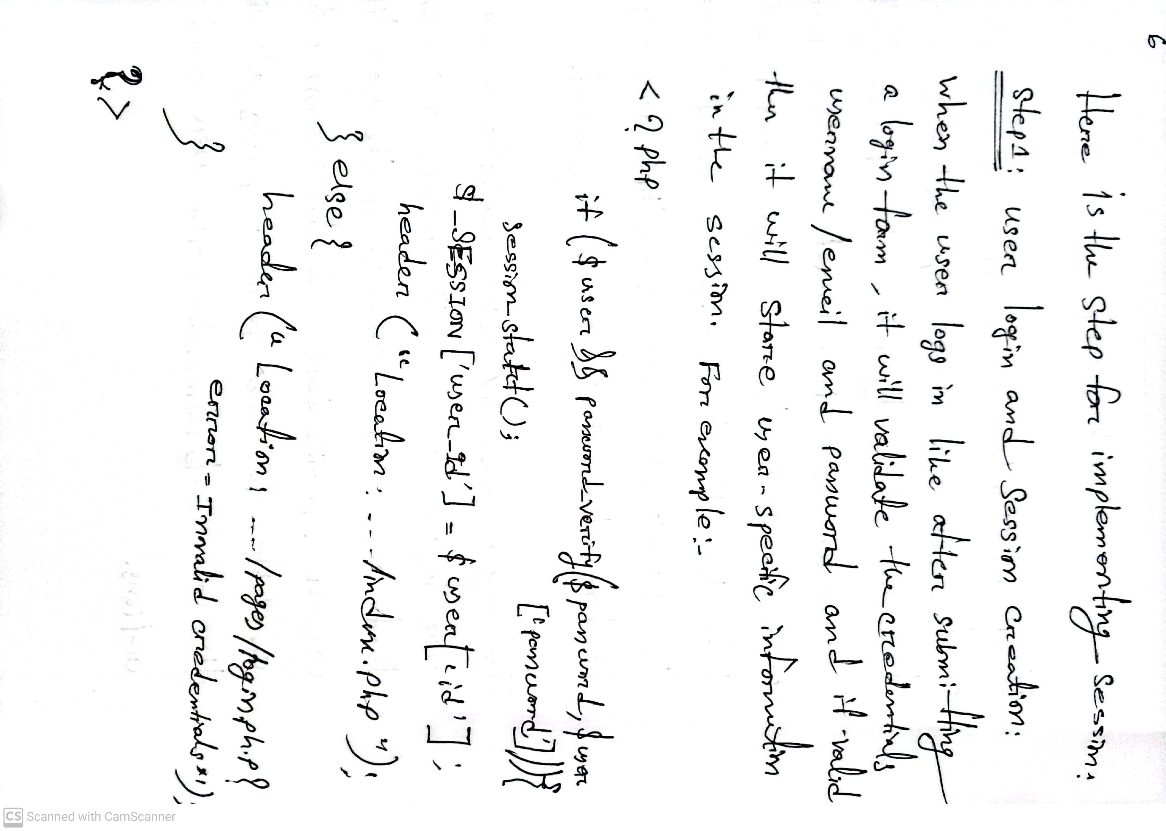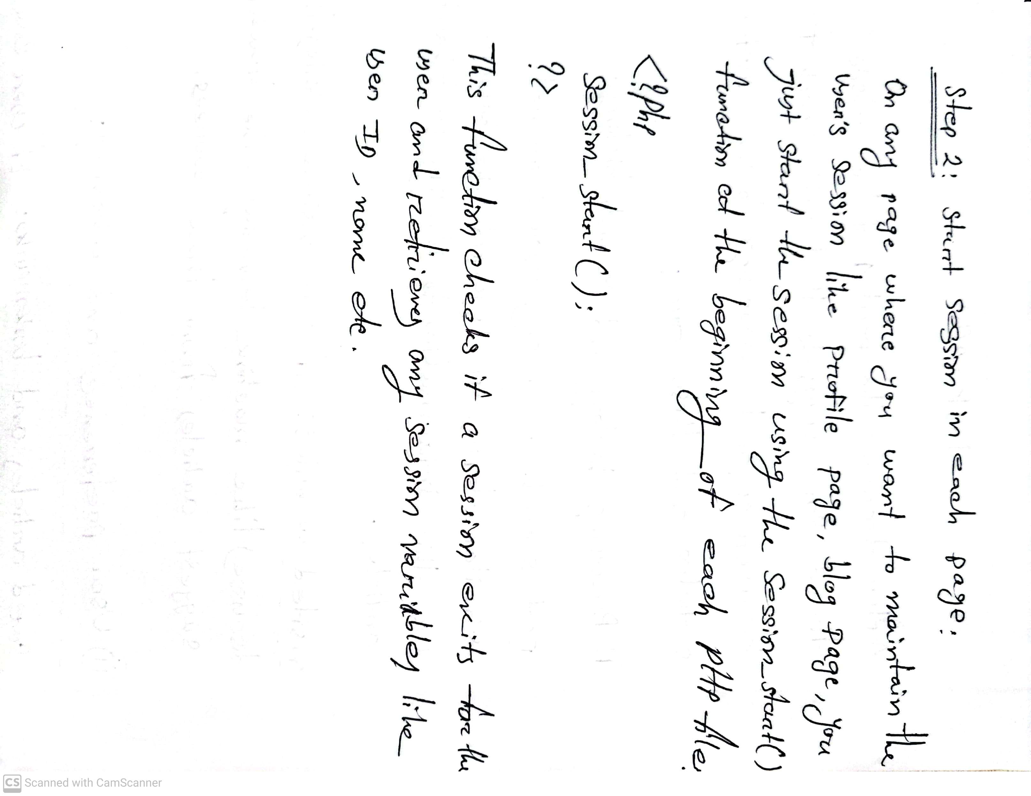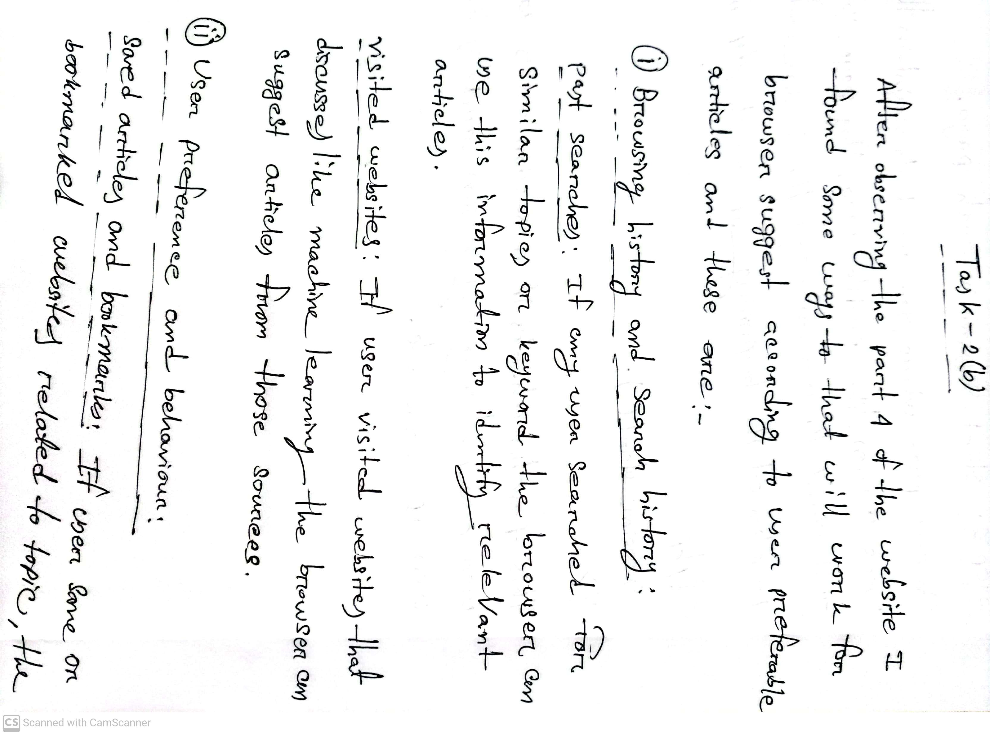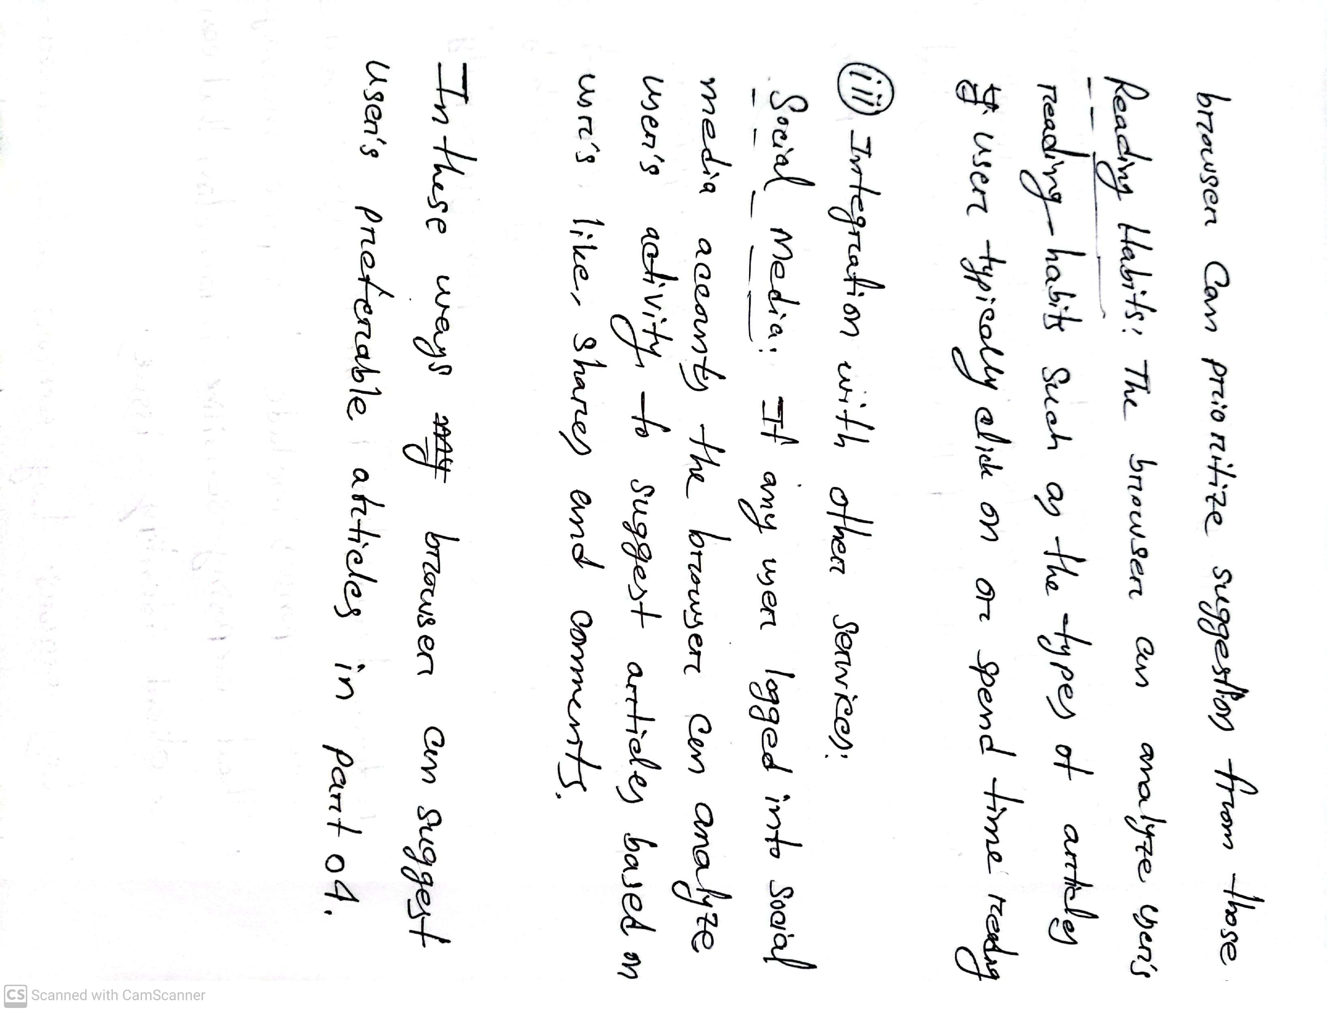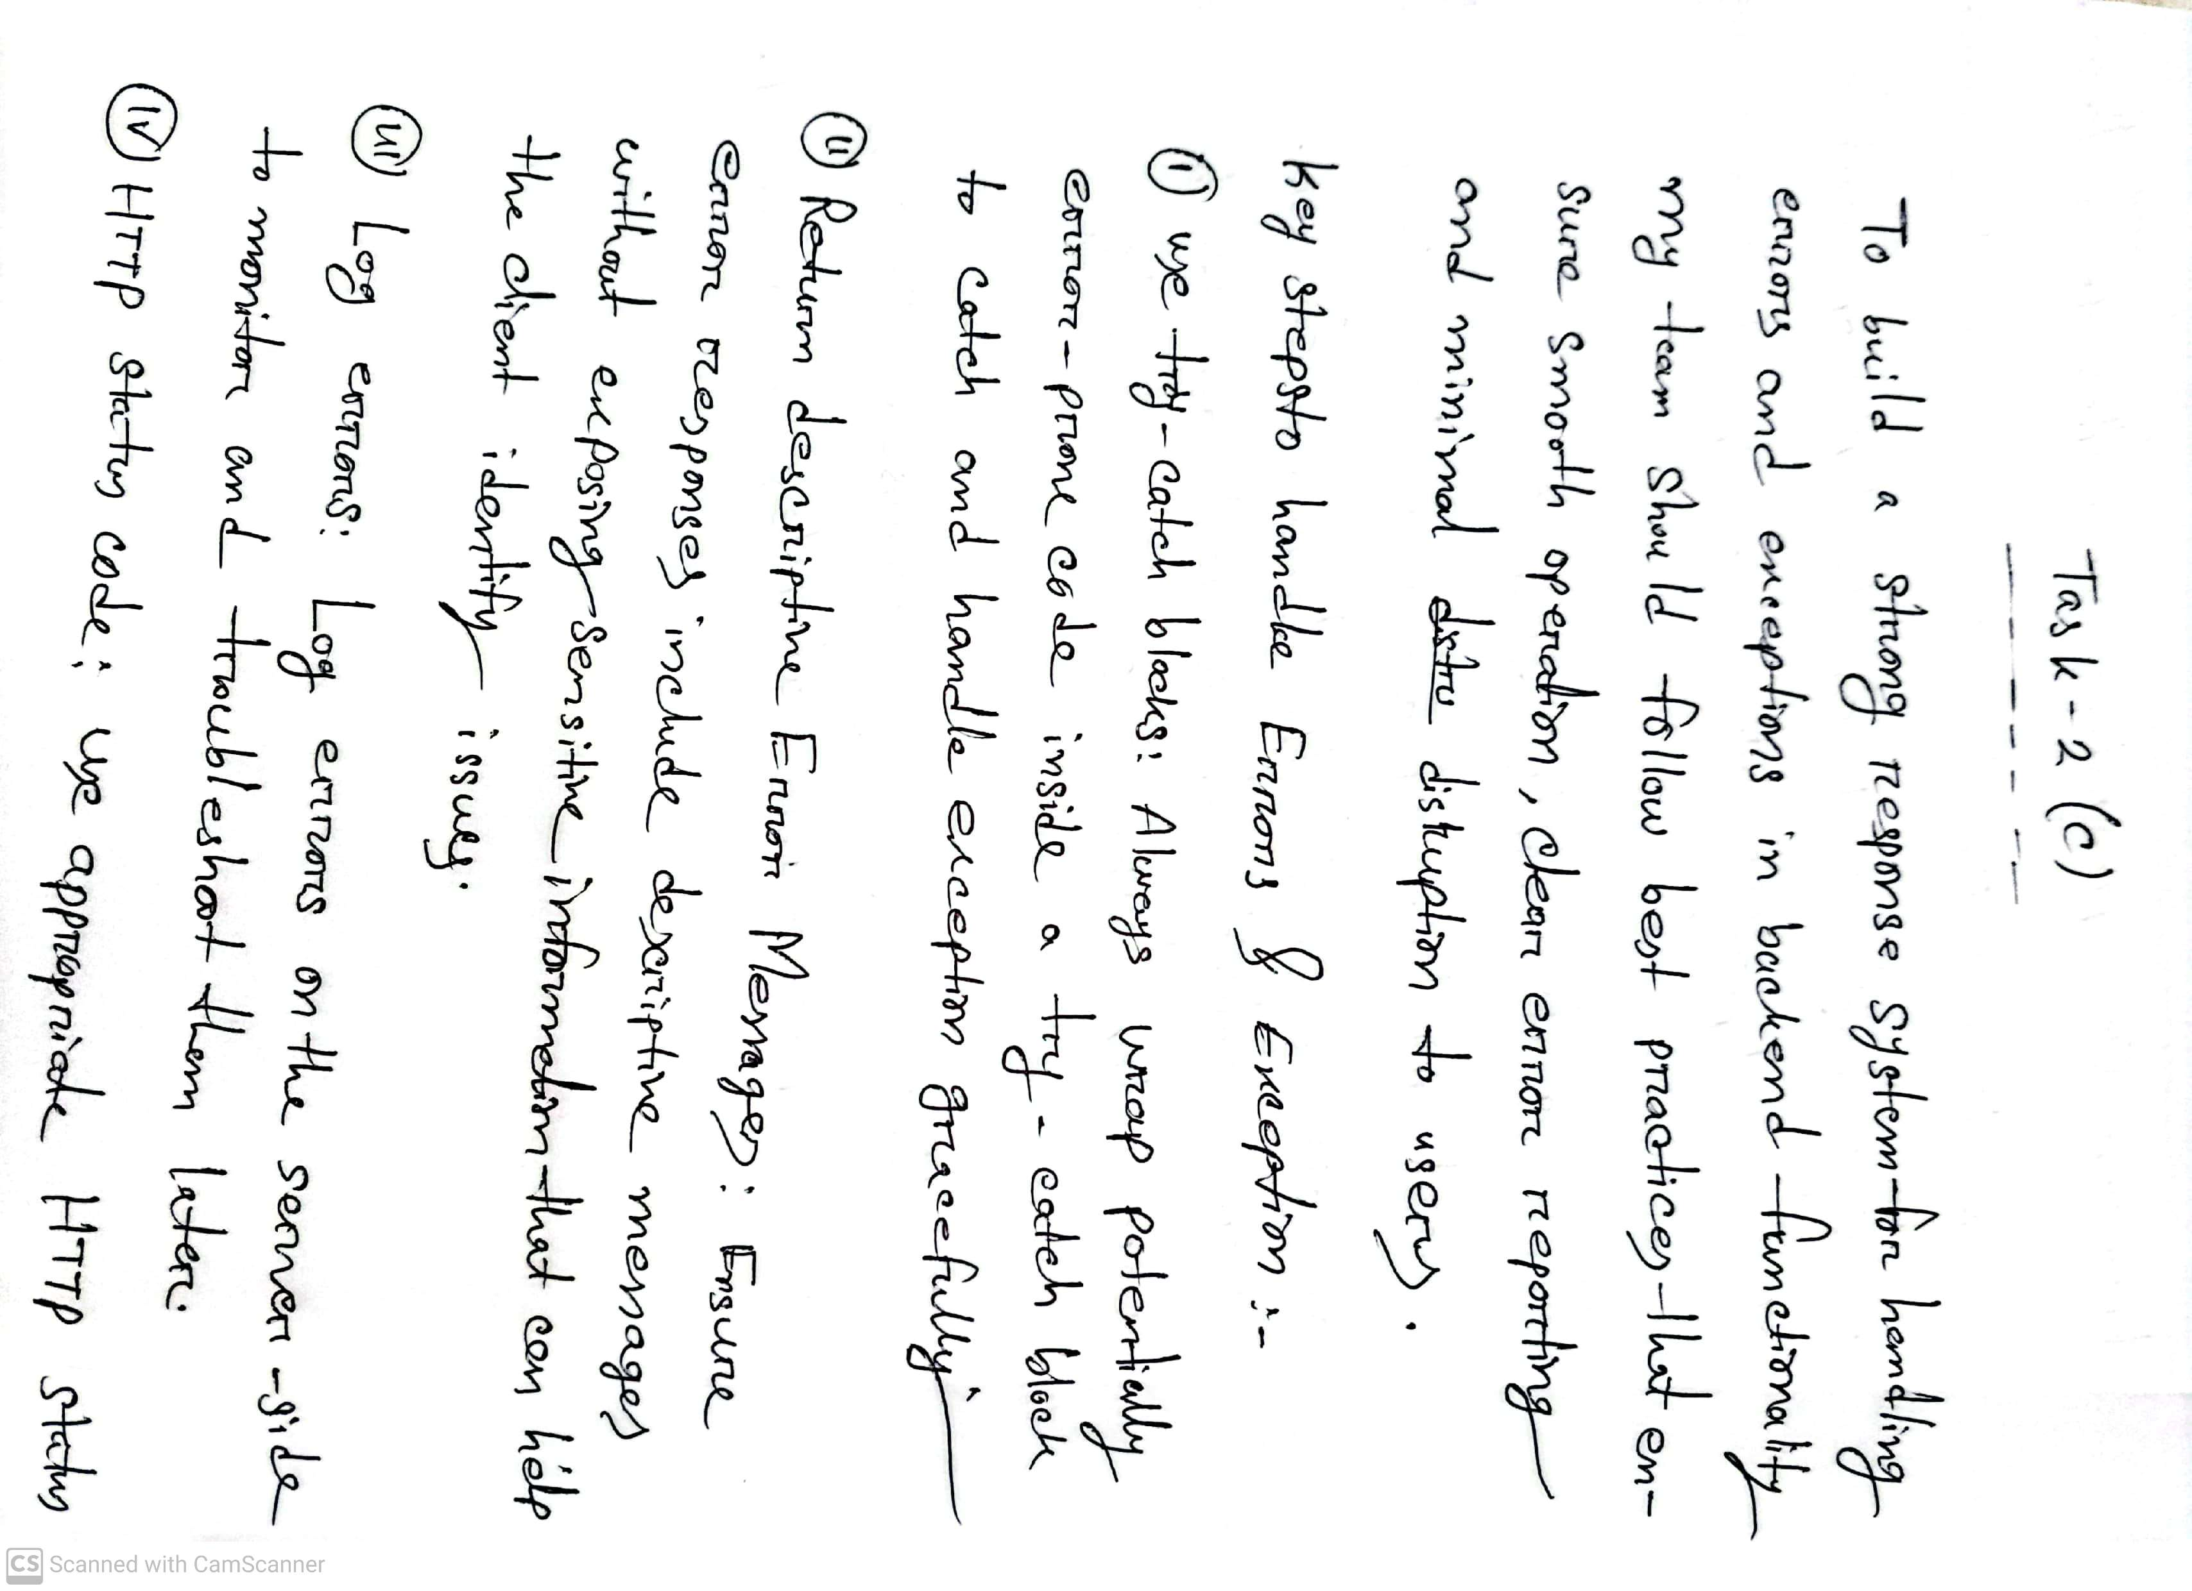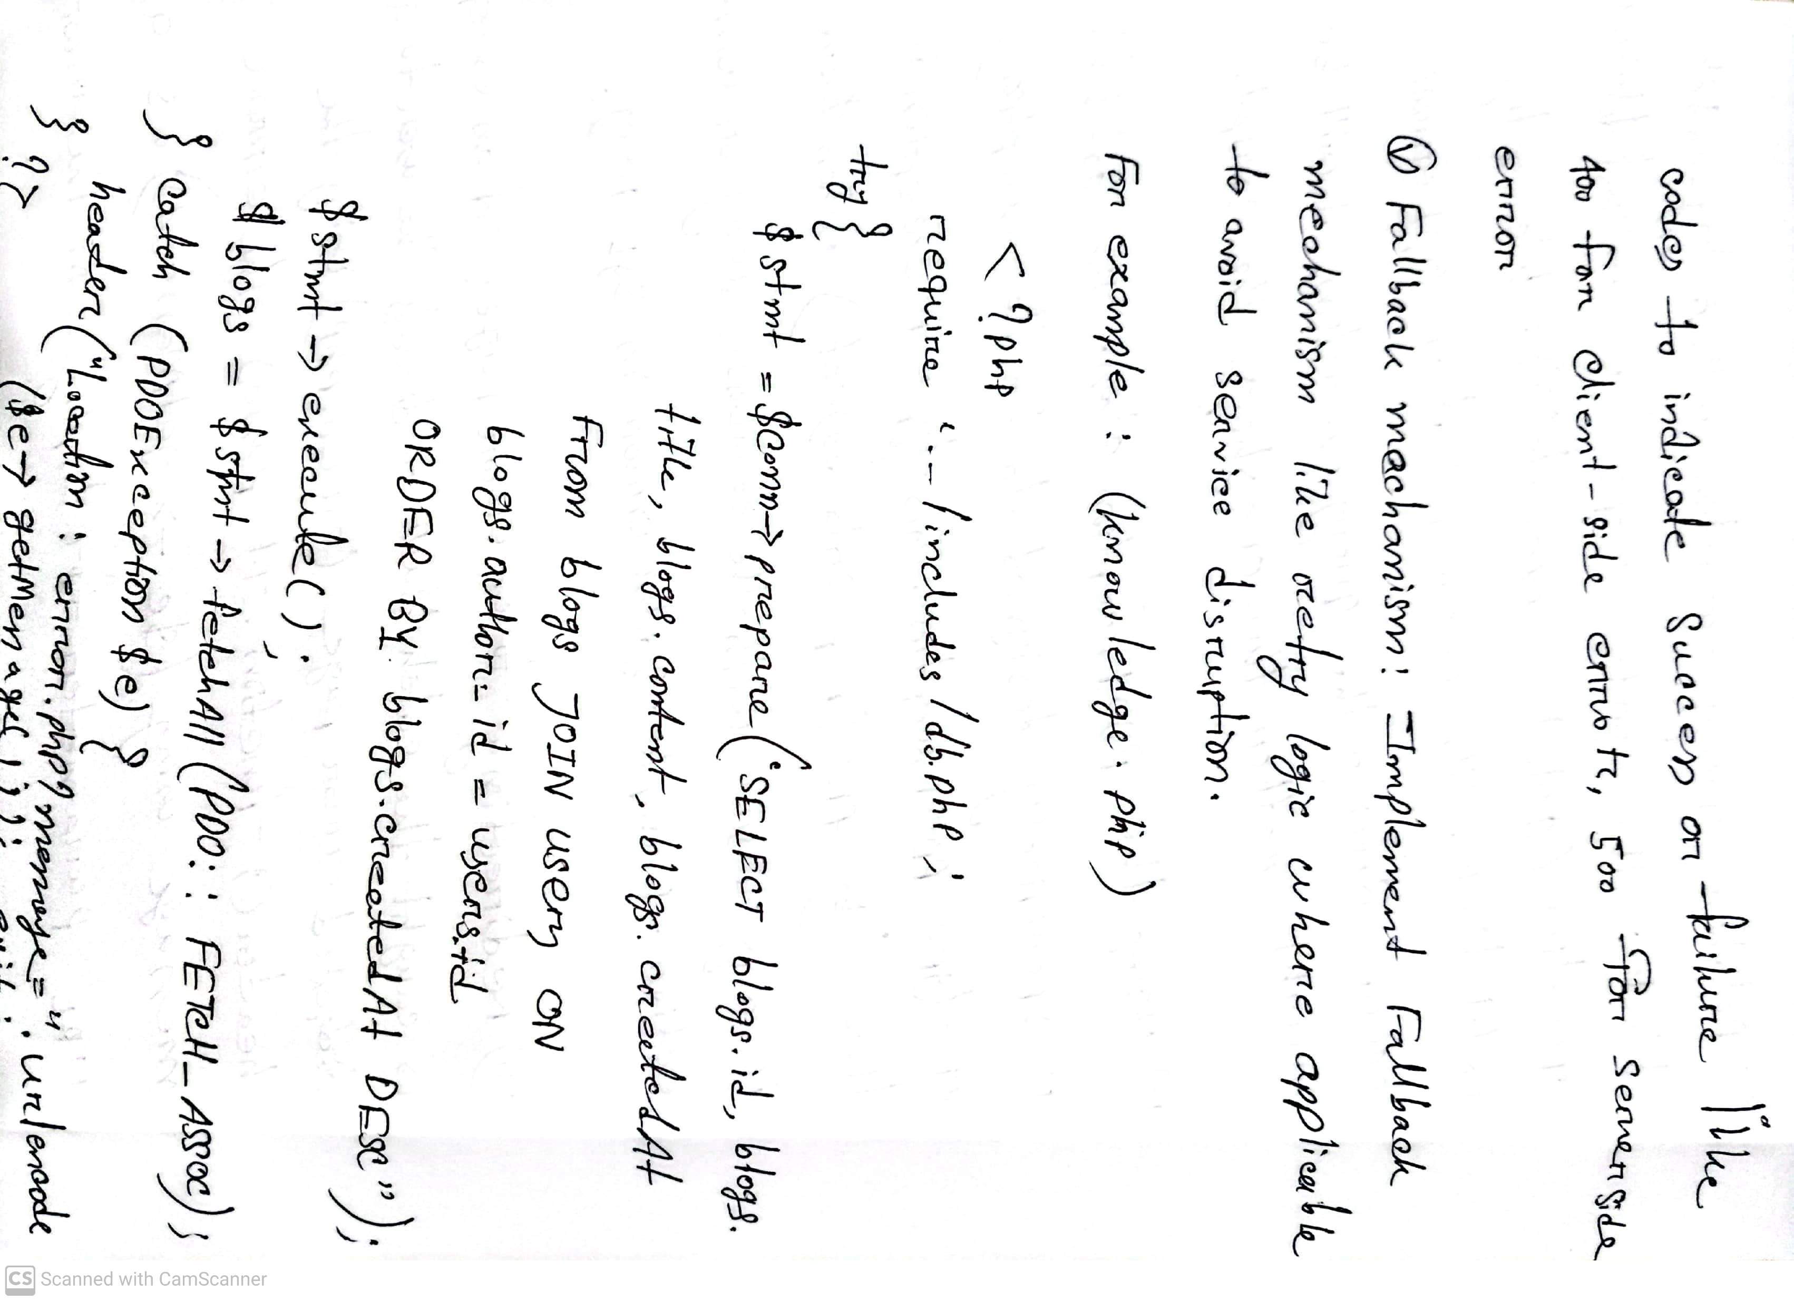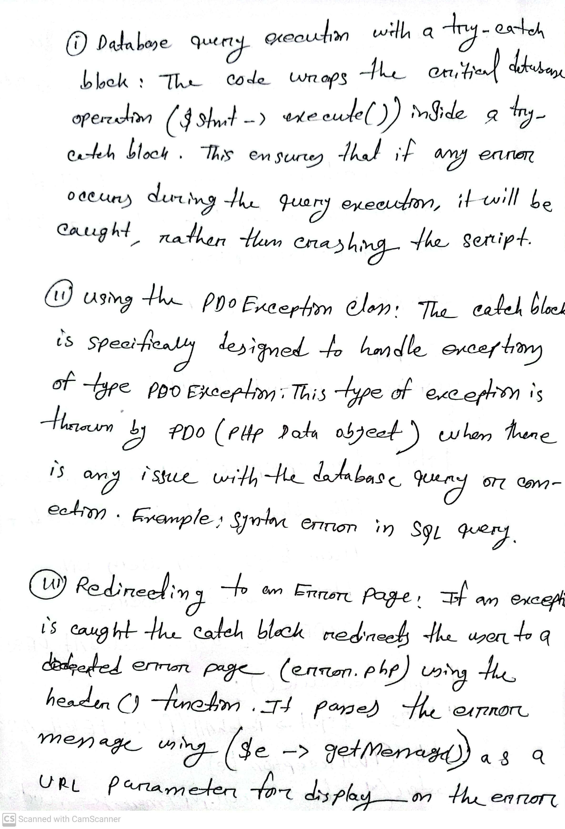

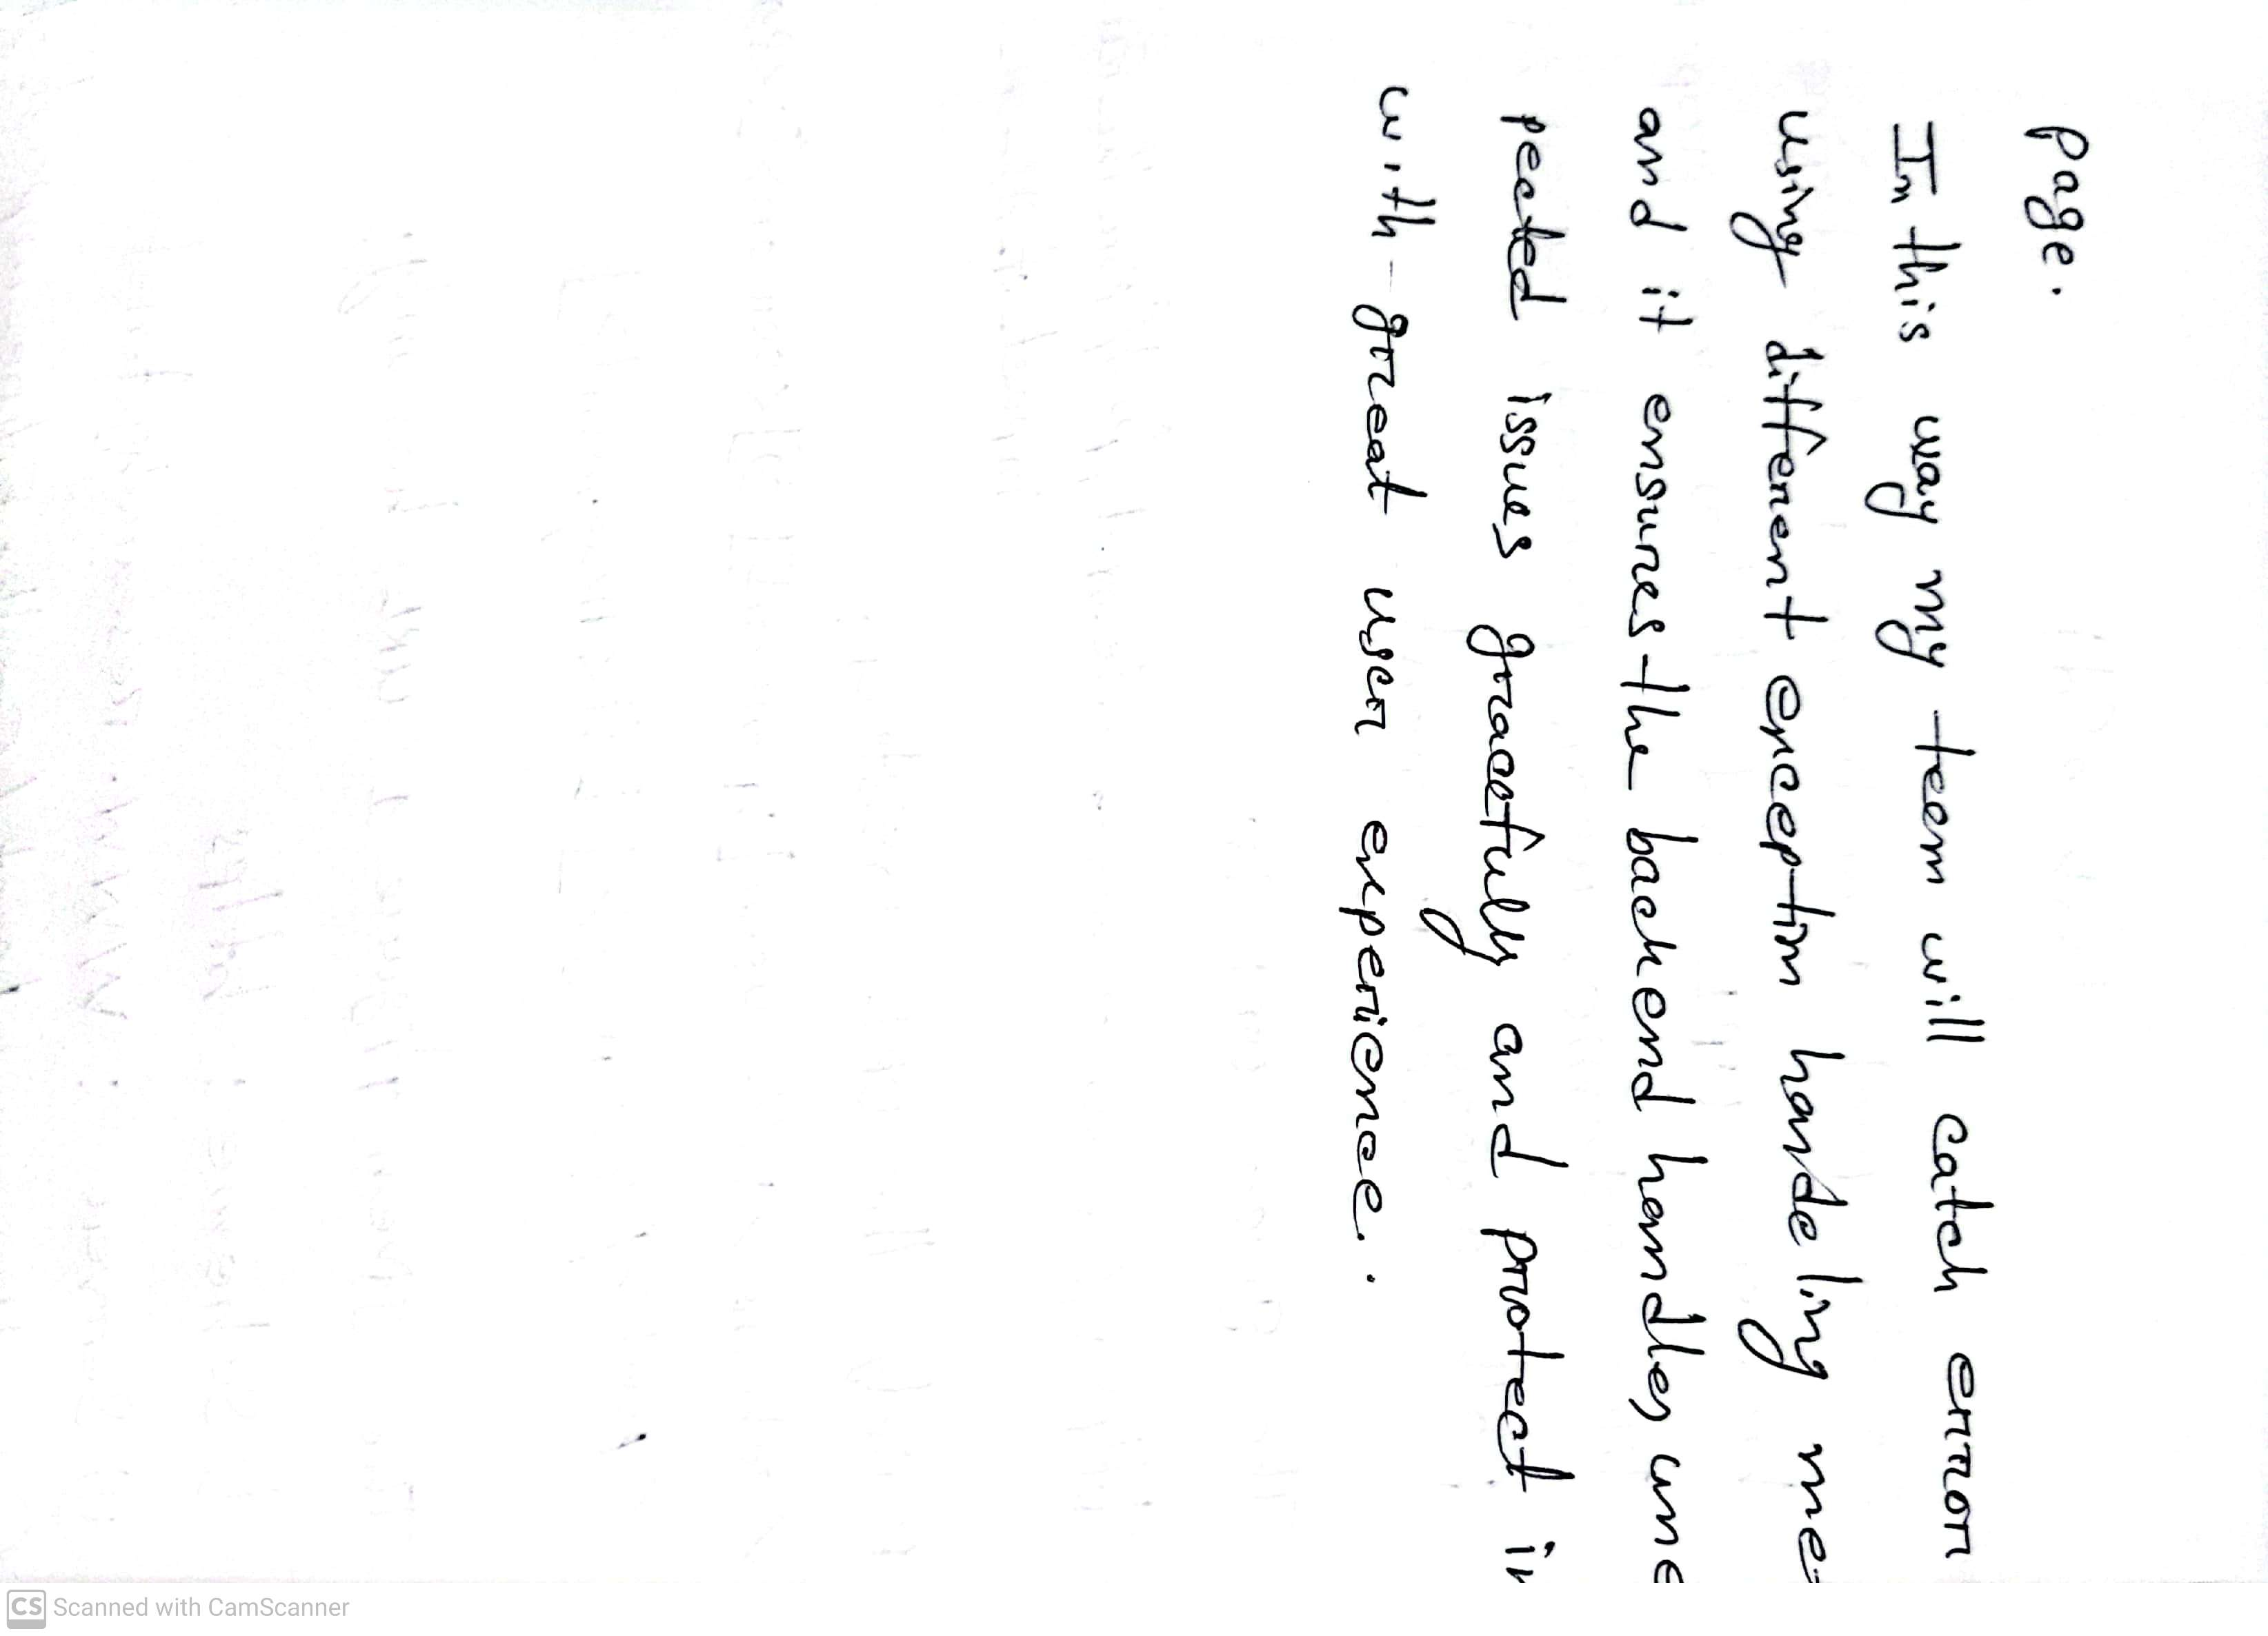 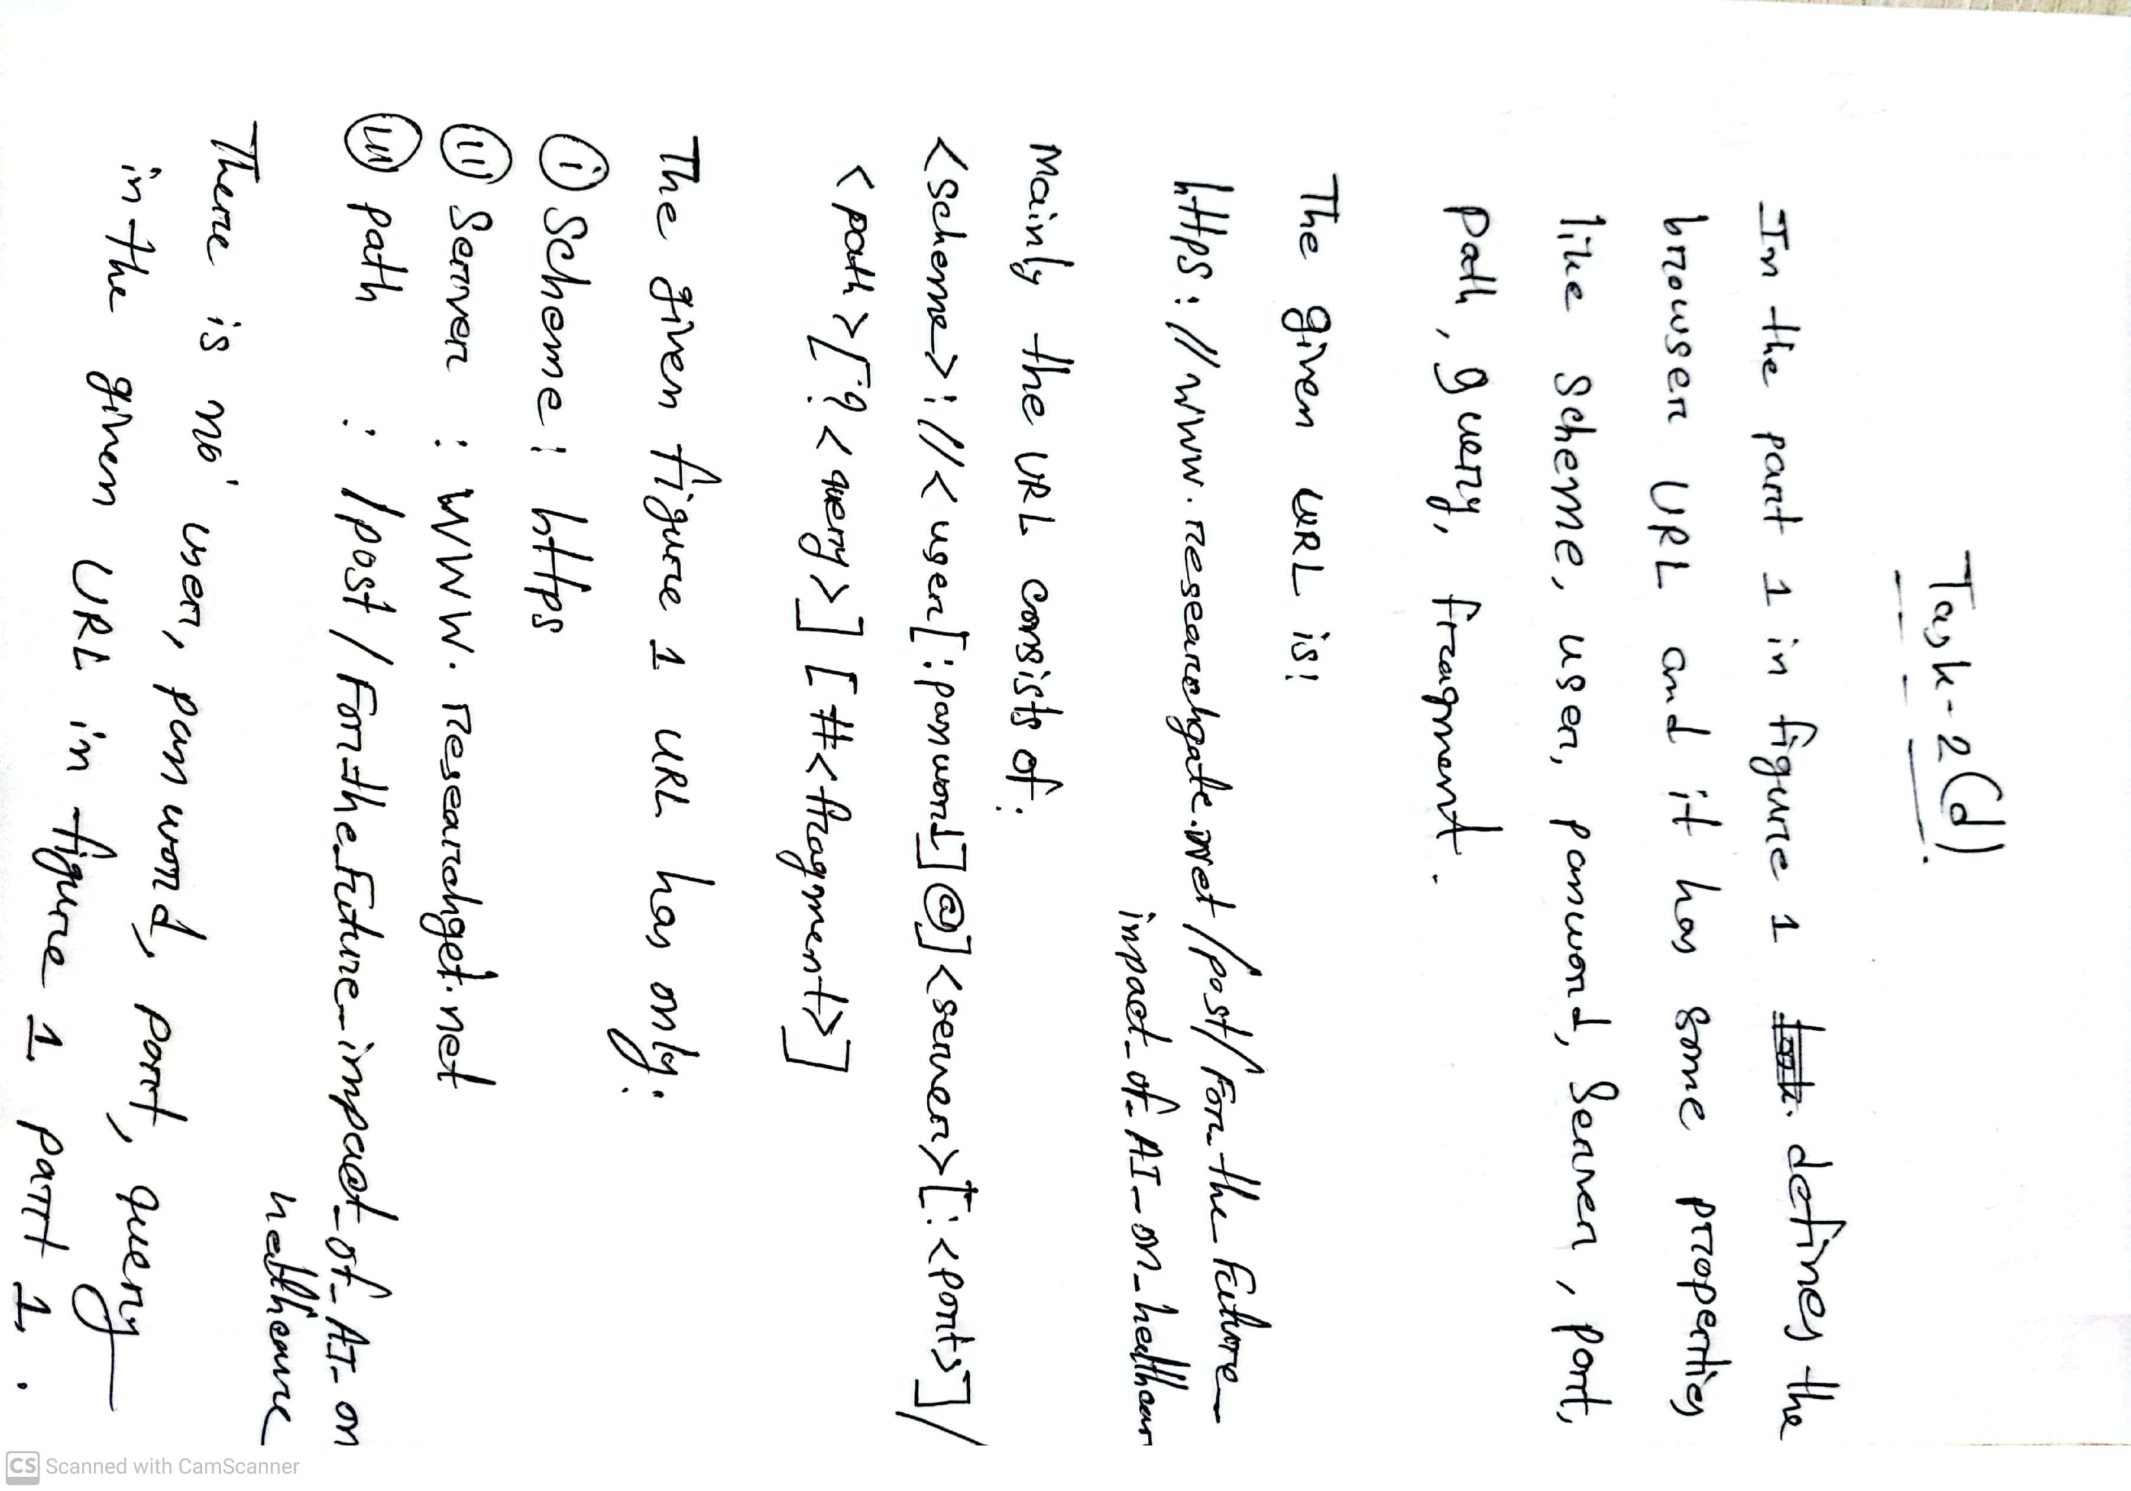

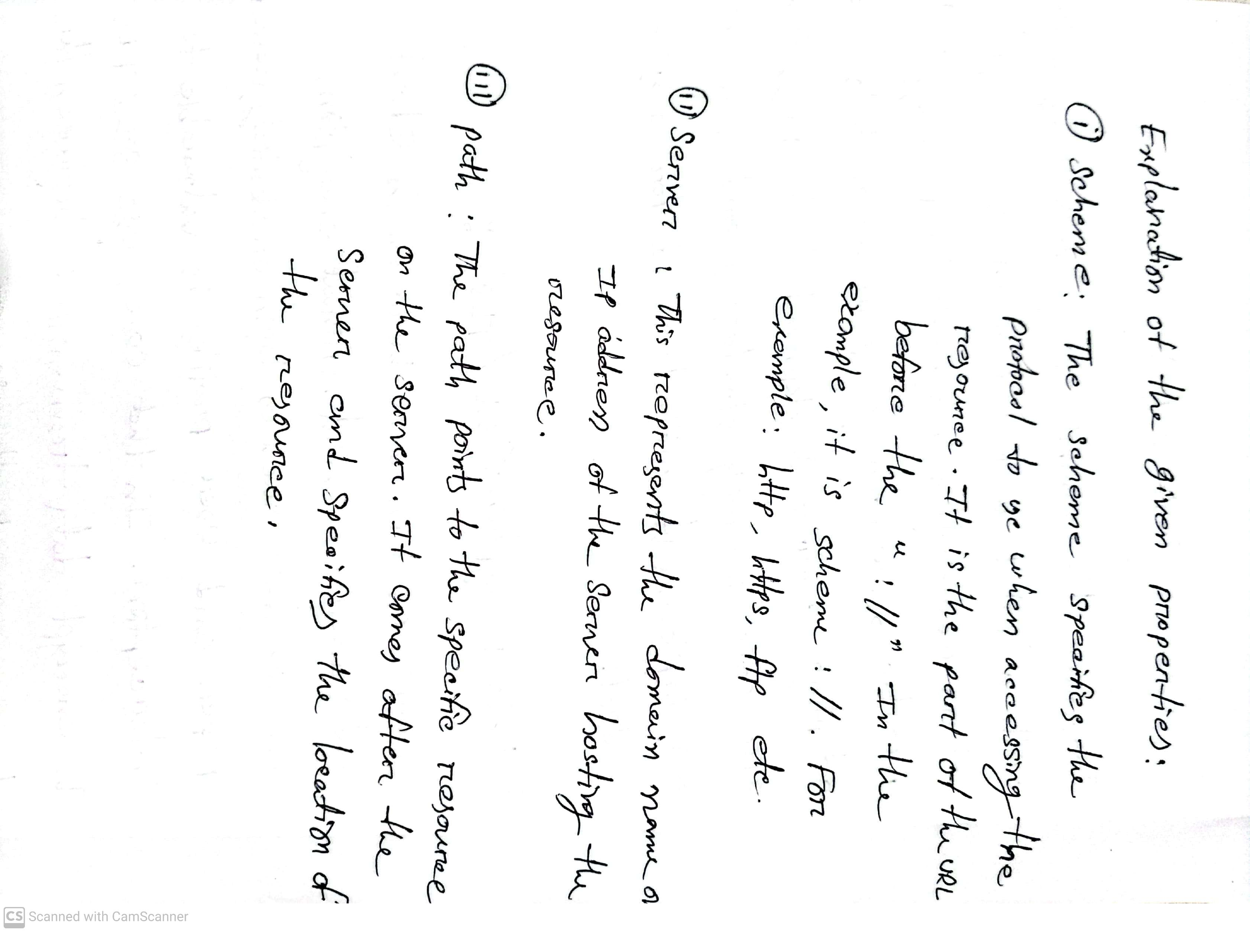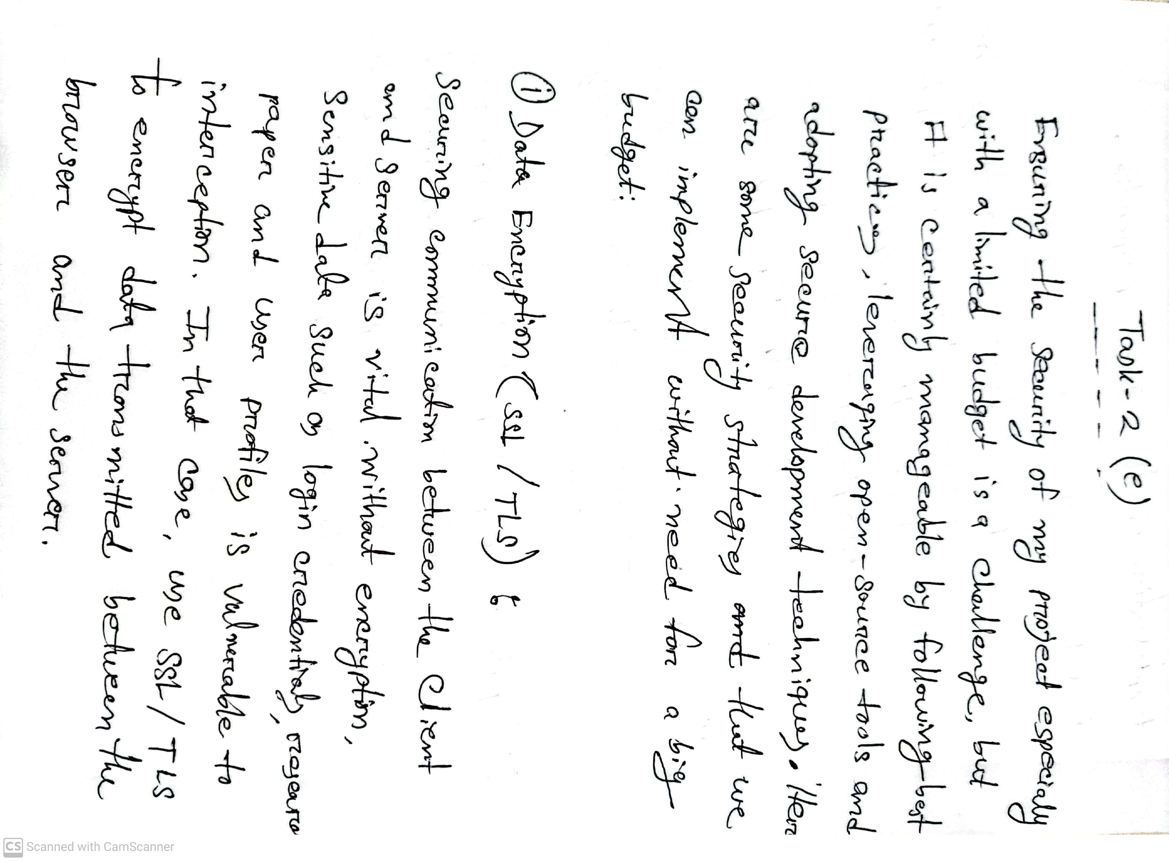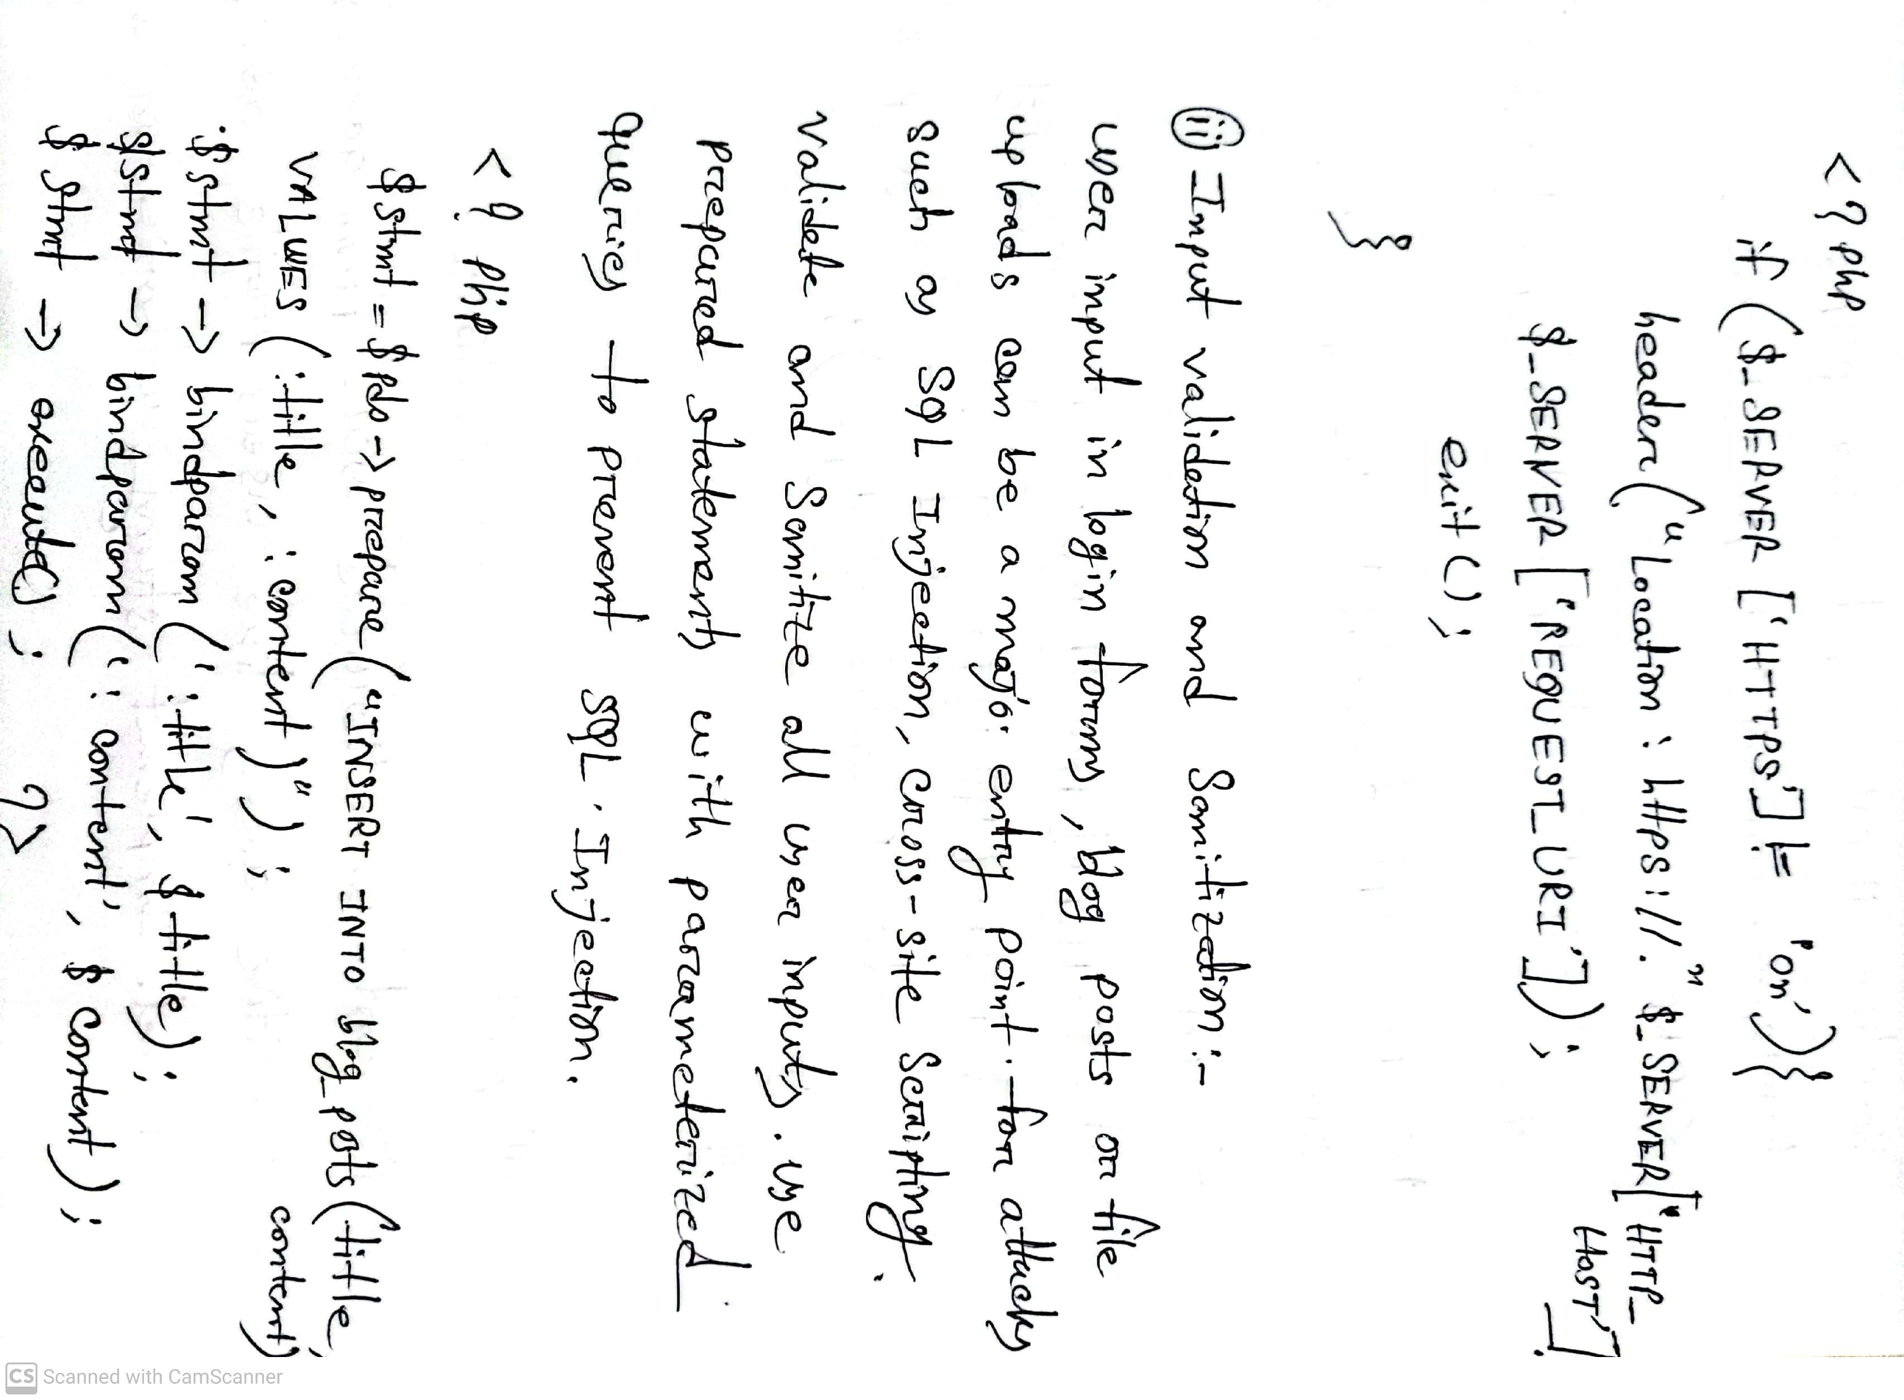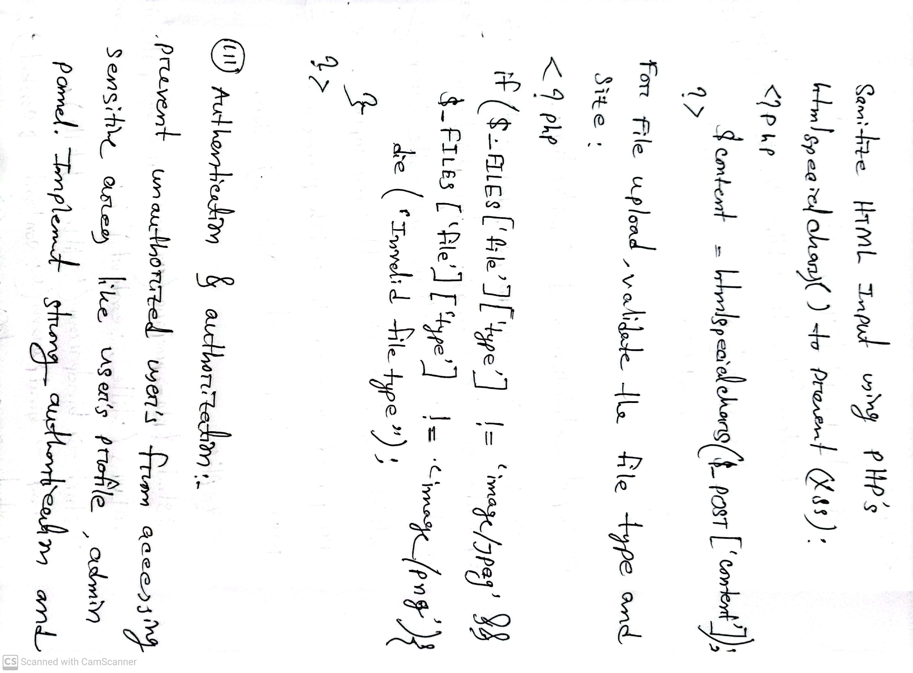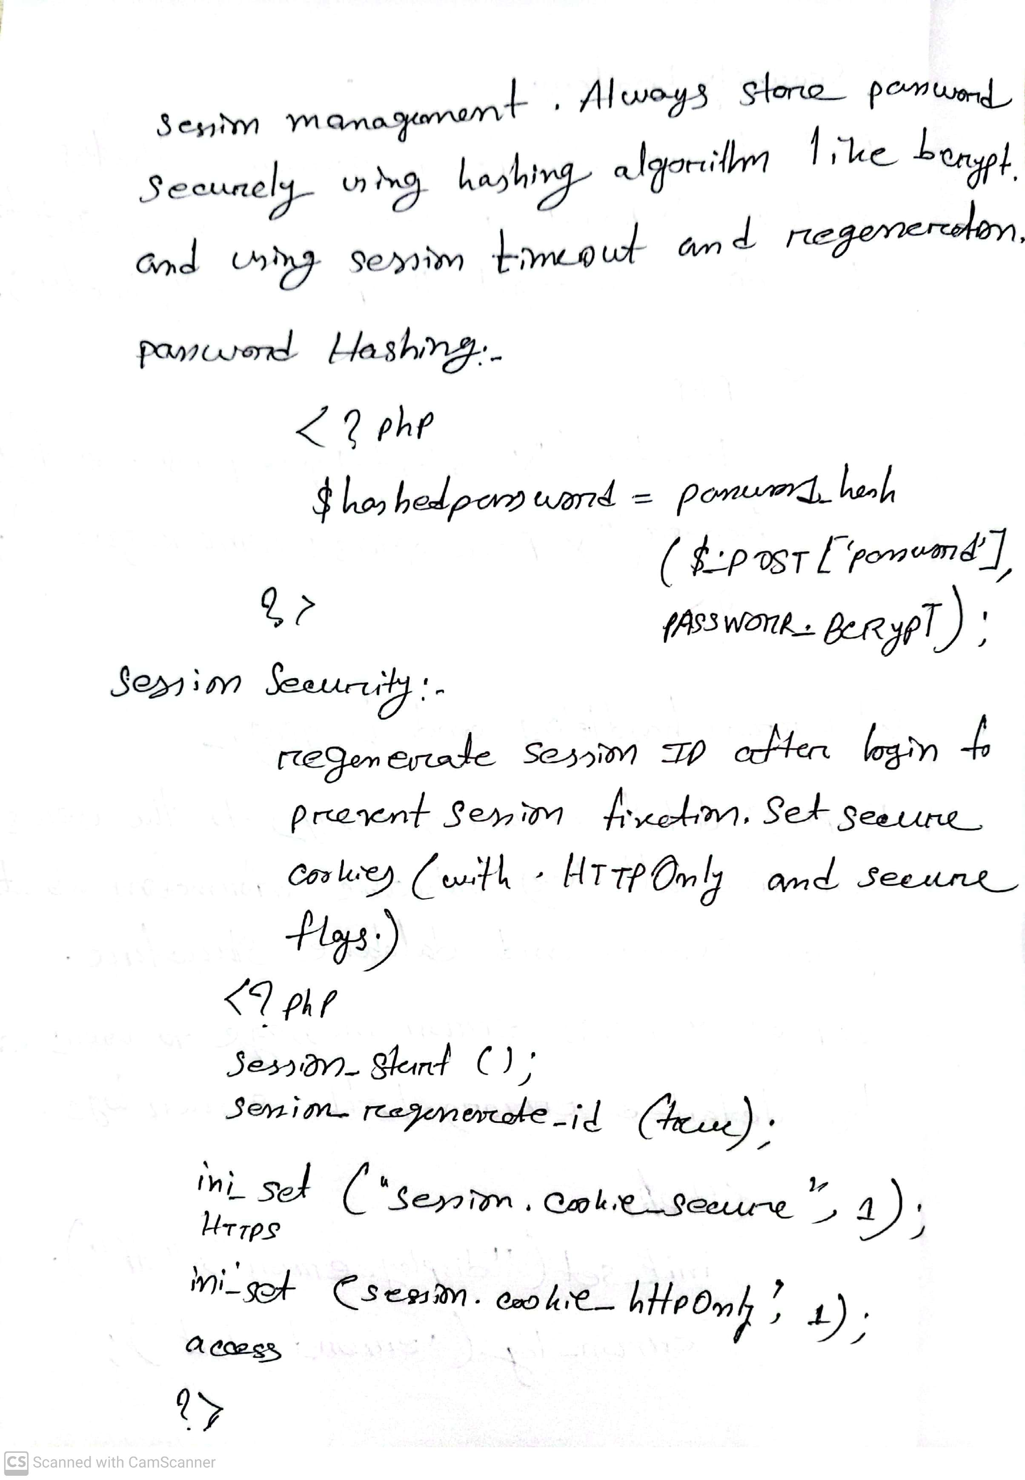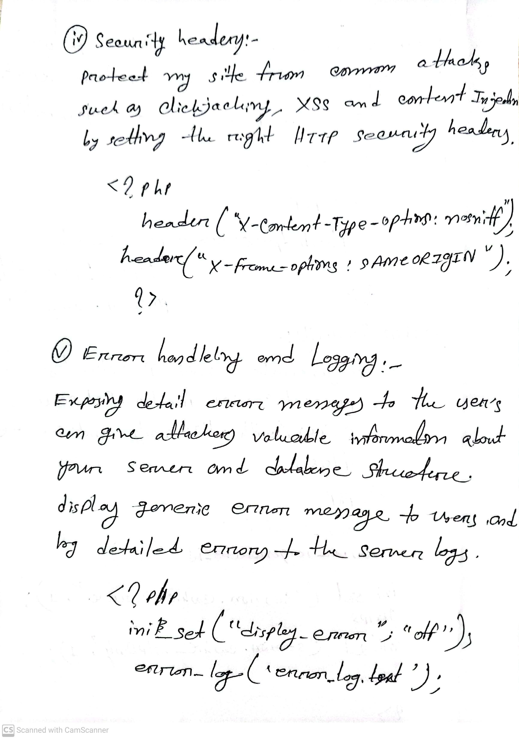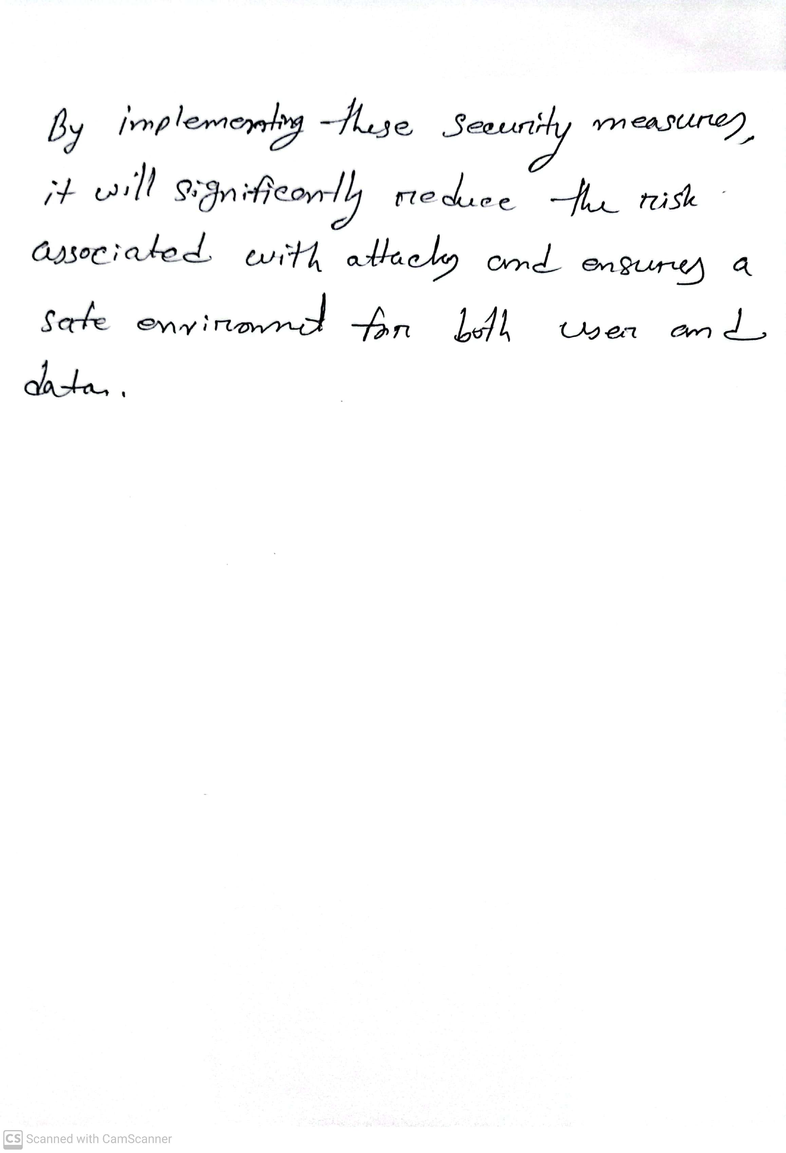

**Task-3 (A)**

**SignUp page code**

<?php

*require* '../includes/db.php';

*if* ($_SERVER['REQUEST_METHOD'] === 'POST') {

    $name = $_POST['name'];

    $email = $_POST['email'];

    $password = password_hash($_POST['password'], PASSWORD_BCRYPT);

    $expertise = $_POST['expertise'];

*try* {

        $stmt = $conn->prepare("INSERT INTO users (name, email, password, expertise) VALUES (:name, :email, :password, :expertise)");

        $stmt->bindParam(':name', $name);

        $stmt->bindParam(':email', $email);

        $stmt->bindParam(':password', $password);

        $stmt->bindParam(':expertise', $expertise);

        $stmt->execute();

        header("Location: ../pages/login.php?success=Account created successfully");

    } *catch* (PDOException $e) {

        header("Location: ../pages/signup.php?error=" . urlencode($e->getMessage()));

    }

}

?>

<!DOCTYPE *html*>

<html *lang*="en">

<head>

    <meta *charset*="UTF-8">

    <meta *name*="viewport" *content*="width=device-width, initial-scale=1.0">

    <title>Signup Page</title>

    <link *href*="https://fonts.googleapis.com/css2?family=Roboto:wght@400;500;700&display=swap" *rel*="stylesheet">

    <style>

        body {

            margin: 0;

            padding: 0;

            font-family: 'Roboto', sans-serif;

            display: flex;

            height: 100vh;

        }

        .container {

            display: flex;

            width: 100%;

        }

        .left-section {

            flex: 1;

            background: linear-gradient(135deg, #ff7e5f, #feb47b);

            color: #fff;

            display: flex;

            flex-direction: column;

            align-items: center;

            justify-content: center;

            padding: 2rem;

            text-align: center;

        }

        .left-section h1 {

            font-size: 2rem;

            margin-bottom: 1rem;

        }

        .left-section p {

            font-size: 1rem;

            line-height: 1.5;

            margin-bottom: 1.5rem;

        }

        .left-section a {

            color: #fff;

            text-decoration: underline;

            font-weight: bold;

        }

        .right-section {

            flex: 1;

            background: #fff;

            display: flex;

            align-items: center;

            justify-content: center;

        }

        .form-container {

            width: 100%;

            max-width: 400px;

            padding: 2rem;

        }

        h2 {

            font-size: 1.8rem;

            margin-bottom: 1.5rem;

            text-align: center;

            color: #333;

        }

        form {

            display: flex;

            flex-direction: column;

        }

        input {

            padding: 0.8rem;

            margin: 0.5rem 0;

            border: 1px solid #ddd;

            border-radius: 4px;

            font-size: 1rem;

        }

        input:focus {

            border-color: #007bff;

            outline: none;

            box-shadow: 0 0 5px rgba(0, 123, 255, 0.5);

        }

        button {

            background-color: #ff7e5f;

            color: #fff;

            border: none;

            padding: 0.8rem;

            margin-top: 1rem;

            border-radius: 4px;

            font-size: 1rem;

            cursor: pointer;

            transition: background-color 0.3s ease;

        }

        button:hover {

            background-color: #ff7e9f;

        }

        .social-buttons {

            display: flex;

            justify-content: center;

            margin-top: 1rem;

        }

        .social-buttons button {

            background: #fff;

            border: 1px solid #ddd;

            color: #333;

            padding: 0.5rem 1rem;

            border-radius: 4px;

            margin: 0 0.5rem;

            cursor: pointer;

            font-size: 0.9rem;

            display: flex;

            align-items: center;

        }

        .social-buttons button:hover {

            border-color: #007bff;

        }

        .footer {

            text-align: center;

            margin-top: 1rem;

            font-size: 0.9rem;

        }

        .footer a {

            color: #007bff;

            text-decoration: none;

        }

        .footer a:hover {

            text-decoration: underline;

        }

    </style>

</head>

<body>

    <div *class*="container">

        <div *class*="left-section">

            <h1>Come join us!</h1>

            <p>We are so excited to have you here. If you haven't already, create an account to get access to exclusive offers, rewards, and discounts.</p>

            <a *href*="../pages/login.php">Already have an account? Sign in.</a>

        </div>

        <div *class*="right-section">

            <div *class*="form-container">

                <h2>Signup</h2>

                <form *action*="../scripts/process_signup.php" *method*="POST">

                    <input *type*="text" *name*="name" *placeholder*="Full Name" *required*>

                    <input *type*="email" *name*="email" *placeholder*="Email Address" *required*>

                    <input *type*="password" *name*="password" *placeholder*="Password" *required*>

                    <button *type*="submit">Signup</button>

                </form>

                <div *class*="social-buttons">

                    <button>G</button>

                    <button>F</button>

                    <button>L</button>

                </div>

            </div>

        </div>

    </div>

</body>

</html>

**Resource Upload page:**

<!DOCTYPE *html*>

<html *lang*="en">

<head>

    <meta *charset*="UTF-8">

    <meta *name*="viewport" *content*="width=device-width, initial-scale=1.0">

    <title>Upload Resource - ResearchArchive</title>

    <link *href*="https://cdn.jsdelivr.net/npm/daisyui@4.12.14/dist/full.min.css" *rel*="stylesheet" *type*="text/css" />

    <script *src*="https://cdn.tailwindcss.com"></script>

</head>

<body *class*="font-sans antialiased">

    <?php *include*('../includes/header.php'); ?>

*<!-- Main Content -->*

    <div *class*="flex justify-center items-center min-h-screen px-4 bg-orange-500">

        <div *class*="w-full max-w-lg bg-white shadow-lg rounded-lg p-8">

            <h2 *class*="text-2xl font-bold text-gray-800 text-center mb-6">Upload Resource</h2>

            <form *action*="../scripts/process_upload.php" *method*="POST" *enctype*="multipart/form-data" *class*="space-y-6">

*<!-- Title -->*

                <div>

                    <label *for*="title" *class*="block text-sm font-medium text-gray-700 mb-1">Title</label>

                    <input

*type*="text"

*name*="title"

*id*="title"

*placeholder*="Enter resource title"

*class*="input input-bordered w-full"

*required*>

                </div>

*<!-- Description -->*

                <div>

                    <label *for*="description" *class*="block text-sm font-medium text-gray-700 mb-1">Description</label>

                    <textarea

*name*="description"

*id*="description"

*placeholder*="Enter resource description"

*rows*="4"

*class*="textarea textarea-bordered w-full"

*required*></textarea>

                </div>

*<!-- File Upload -->*

                <div>

                    <label *for*="resource_file" *class*="block text-sm font-medium text-gray-700 mb-1">Resource File</label>

                    <input

*type*="file"

*name*="resource_file"

*id*="resource_file"

*class*="file-input file-input-bordered w-full"

*required*>

                </div>

*<!-- Submit Button -->*

                <button *type*="submit" *class*="w-full bg-orange-500 px-6 py-3 rounded-xl text-white font-bold">Upload</button>

            </form>

        </div>

    </div>

</body>

</html>

**SignUp page Output:**

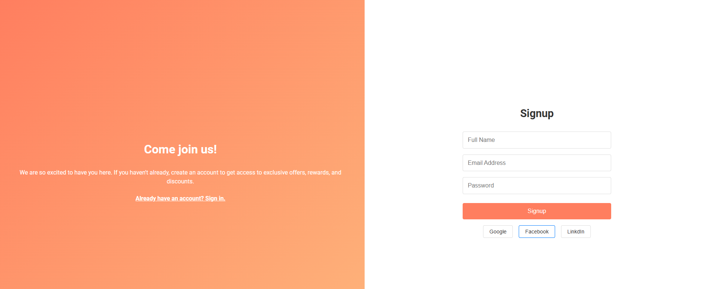

**Resource upload Output:  
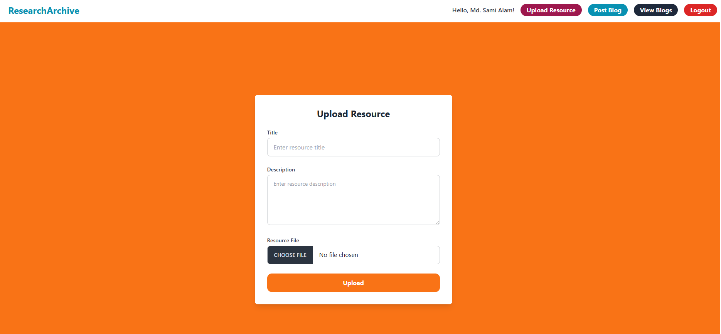**

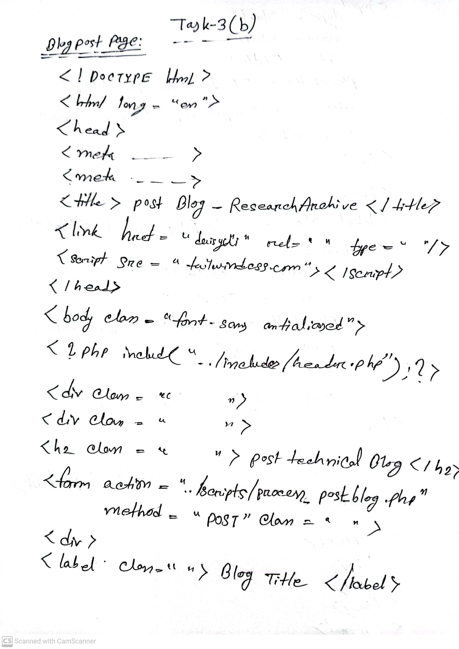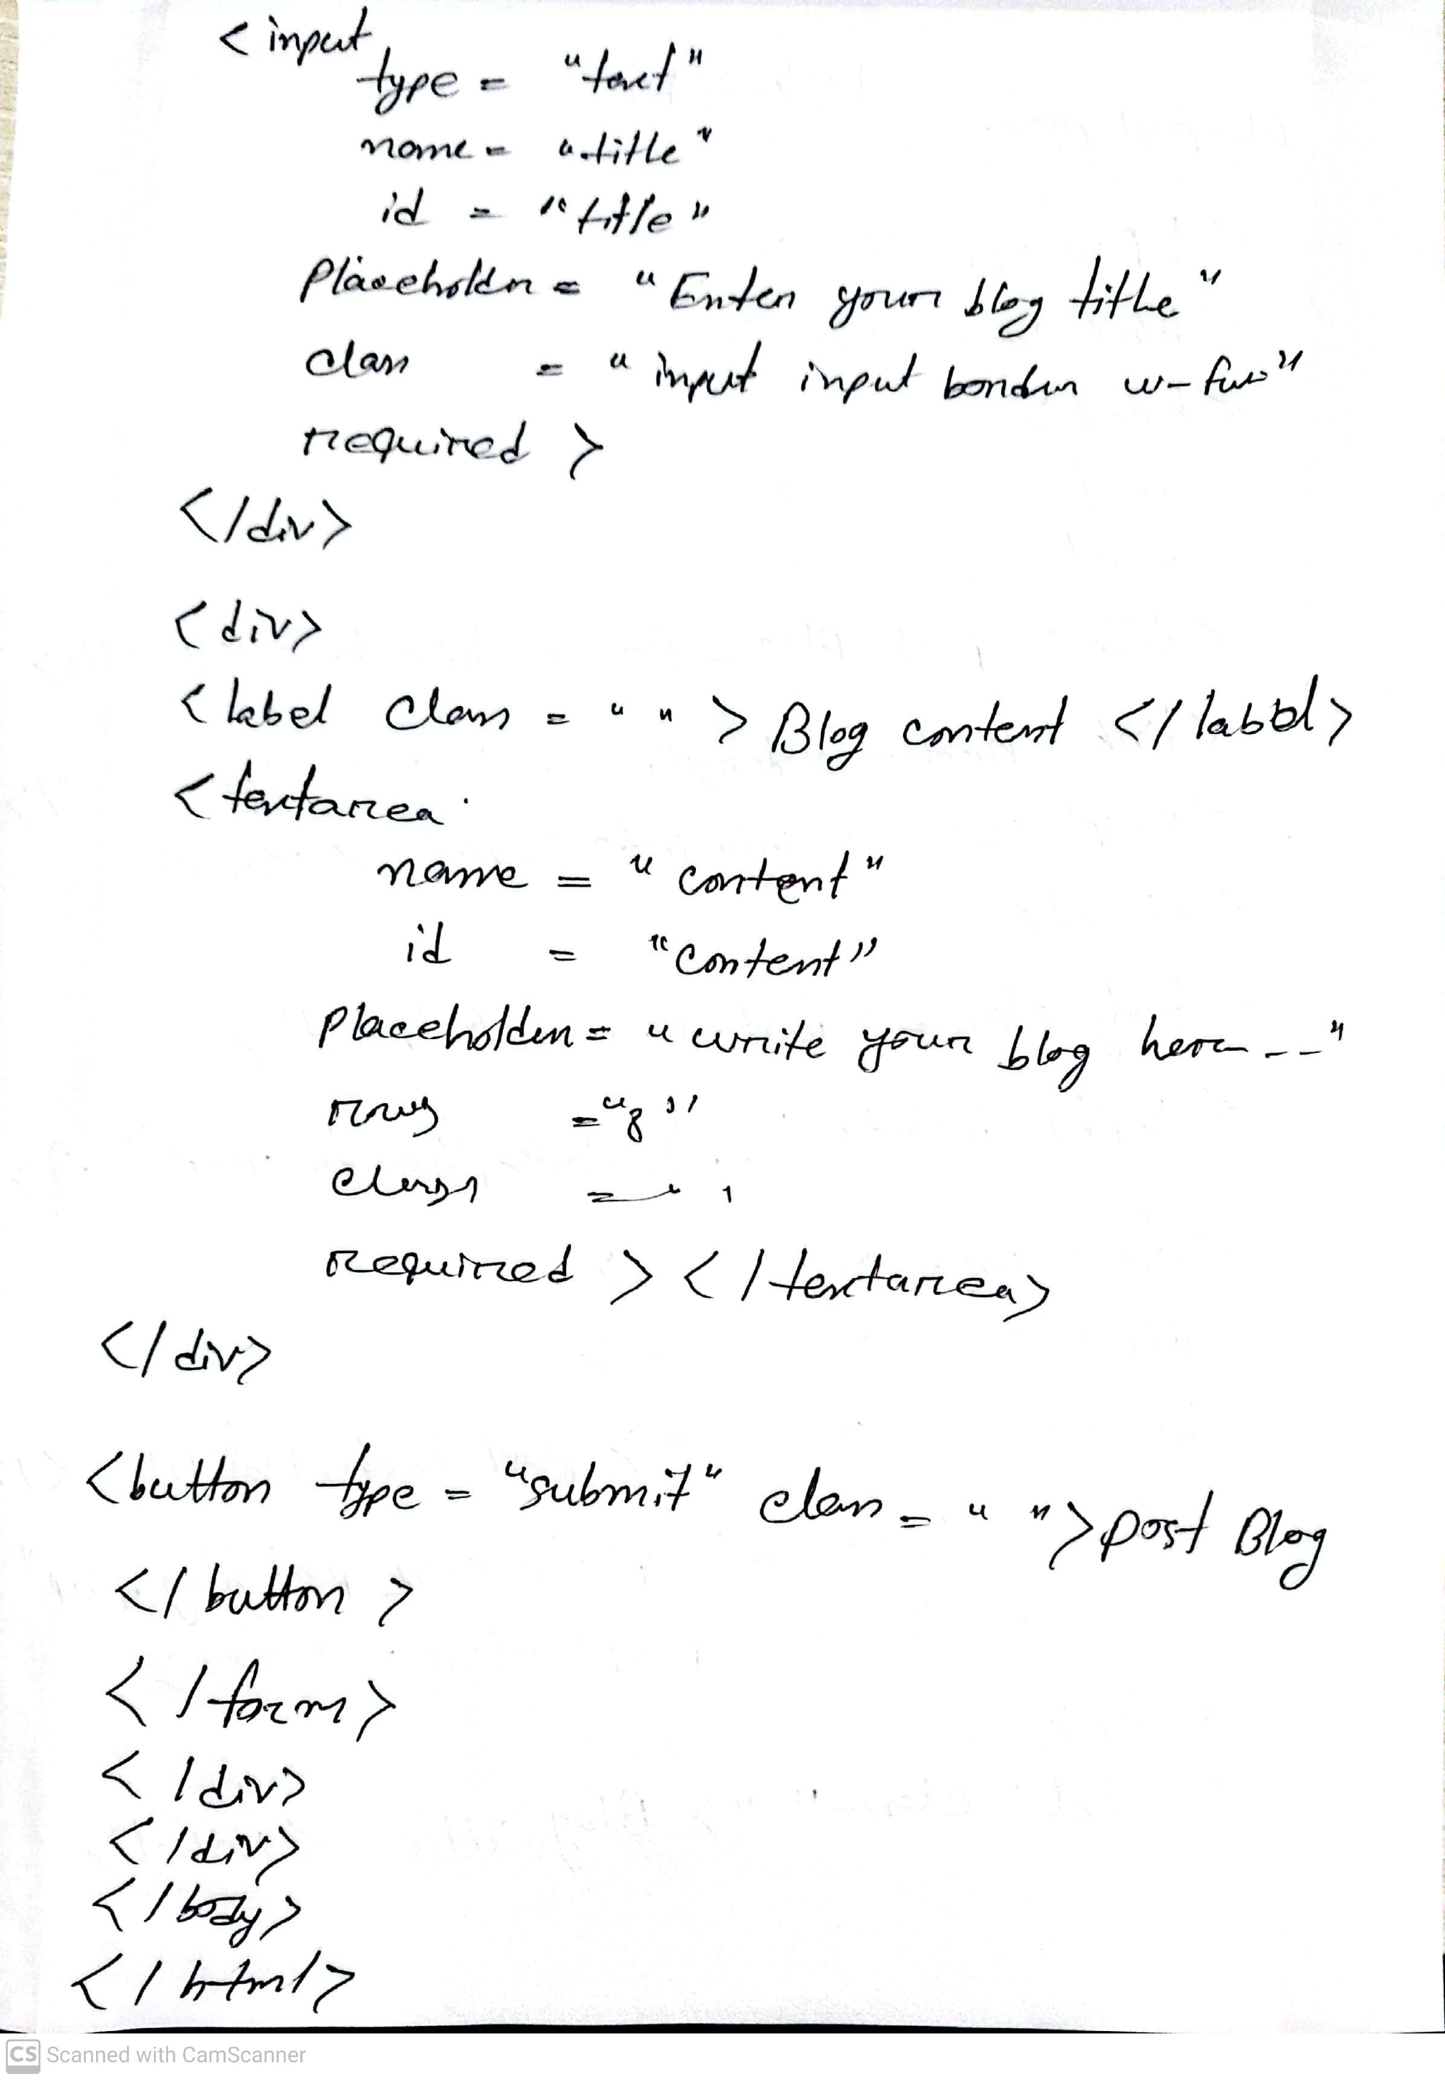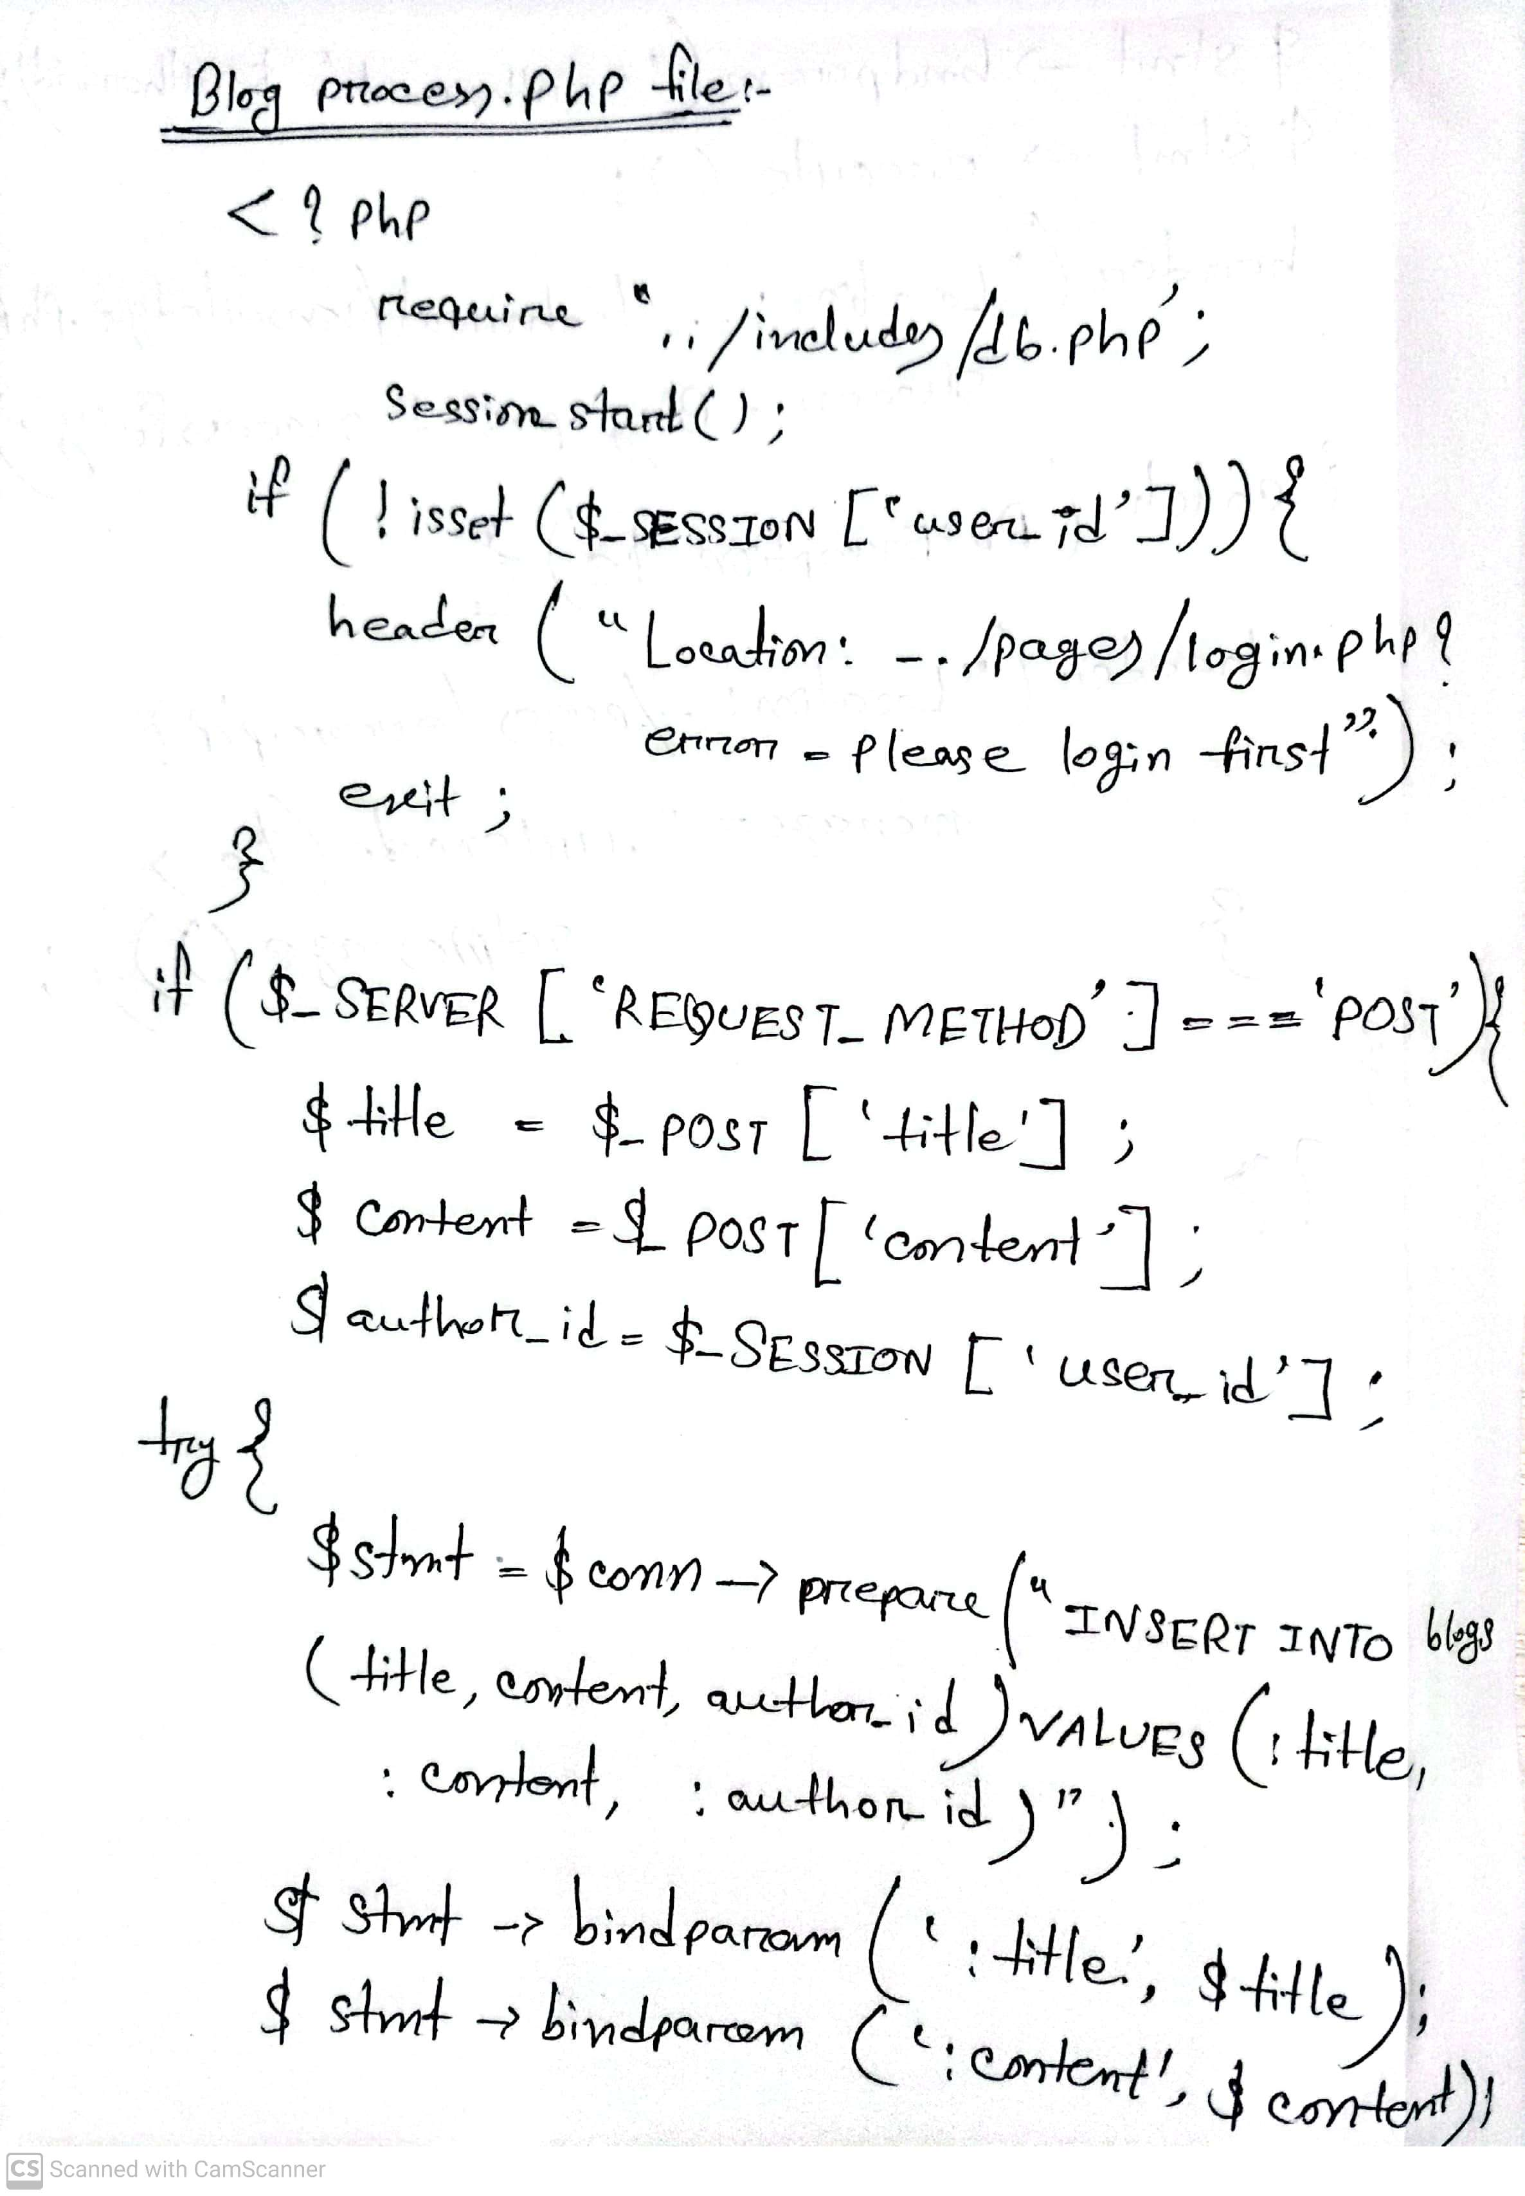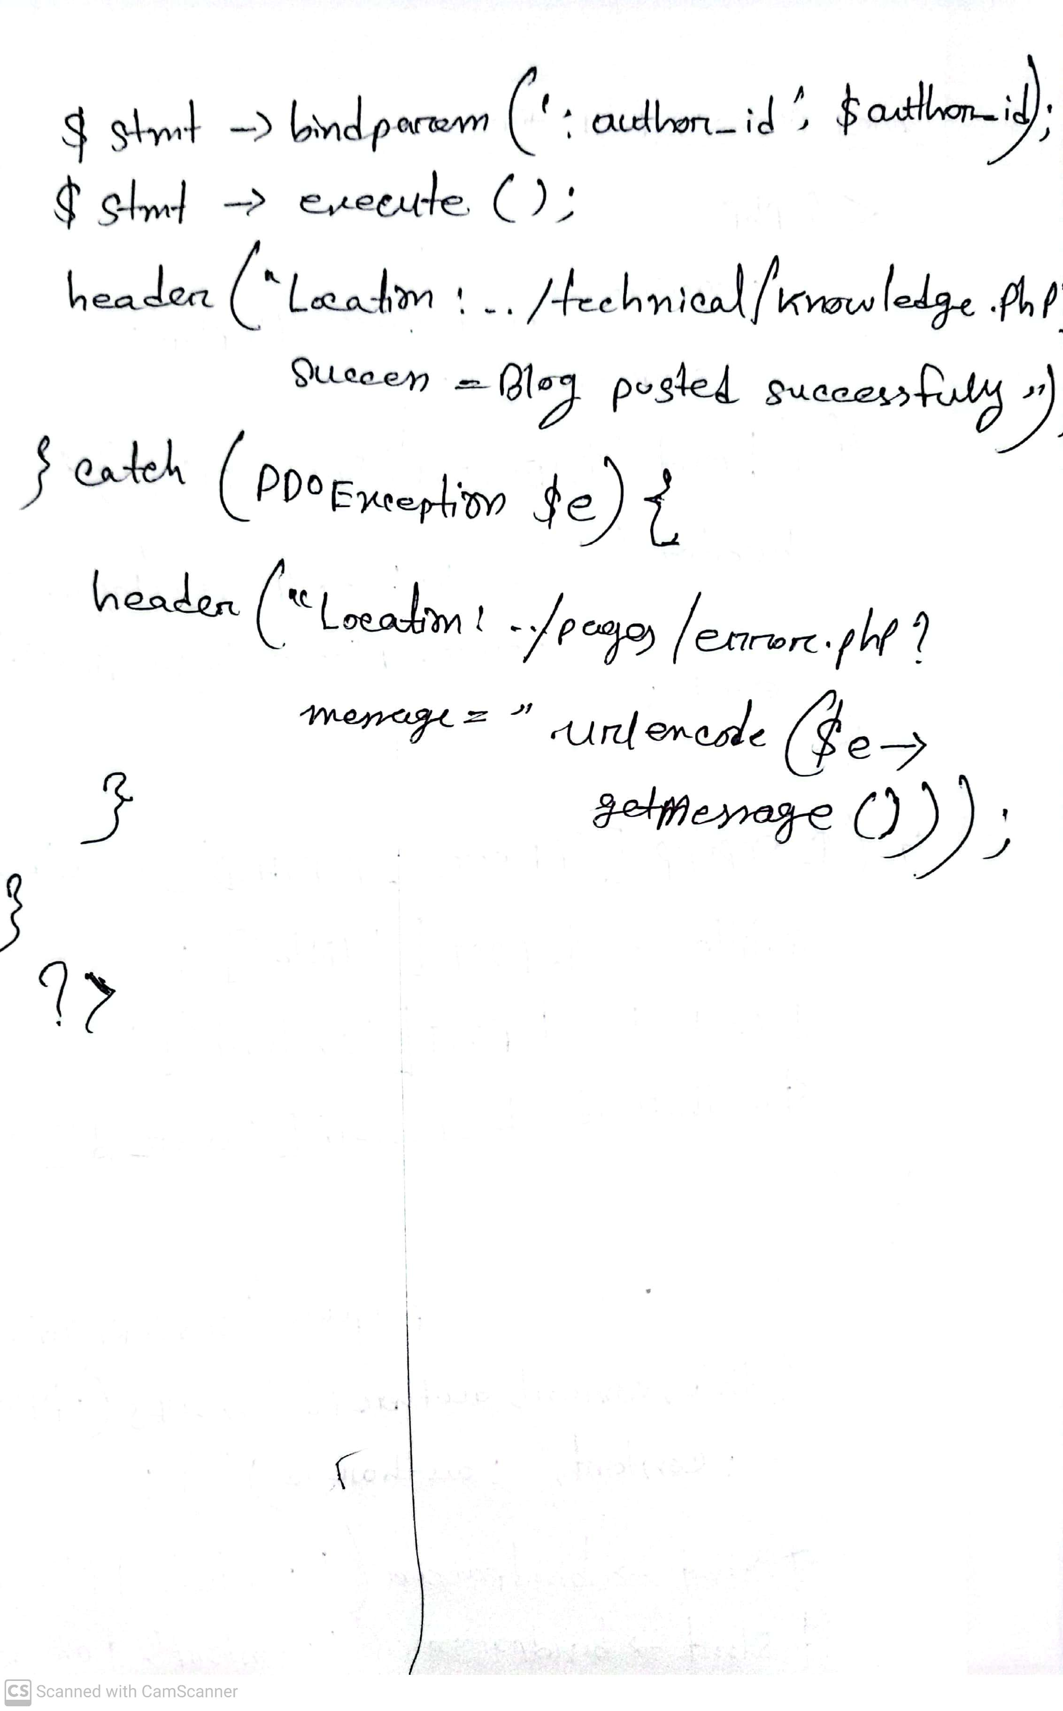

**Post technical blog page:**

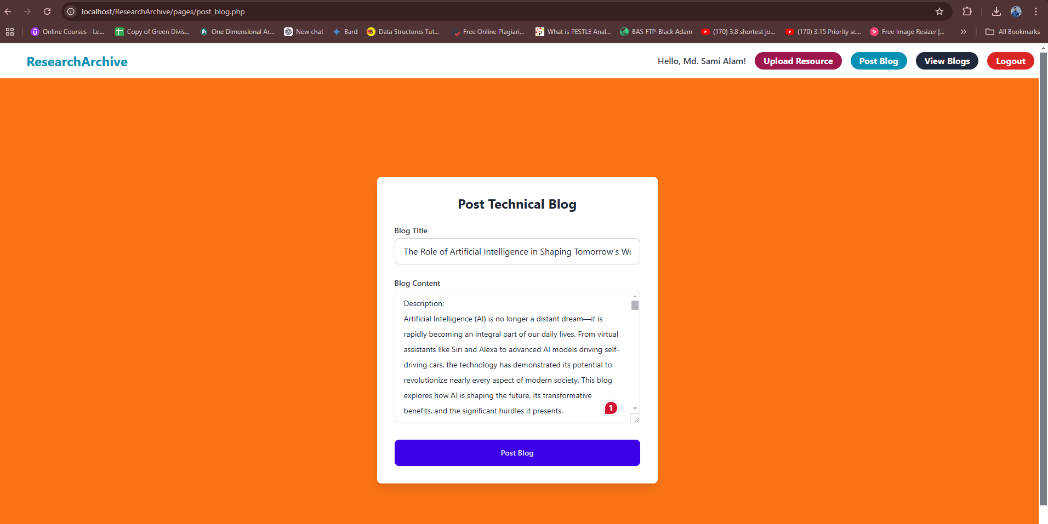

**After posting the technical blog:**

**URL: http://localhost/ResearchArchive/technical/knowledge.php?success=Blog%20posted%20successfully**

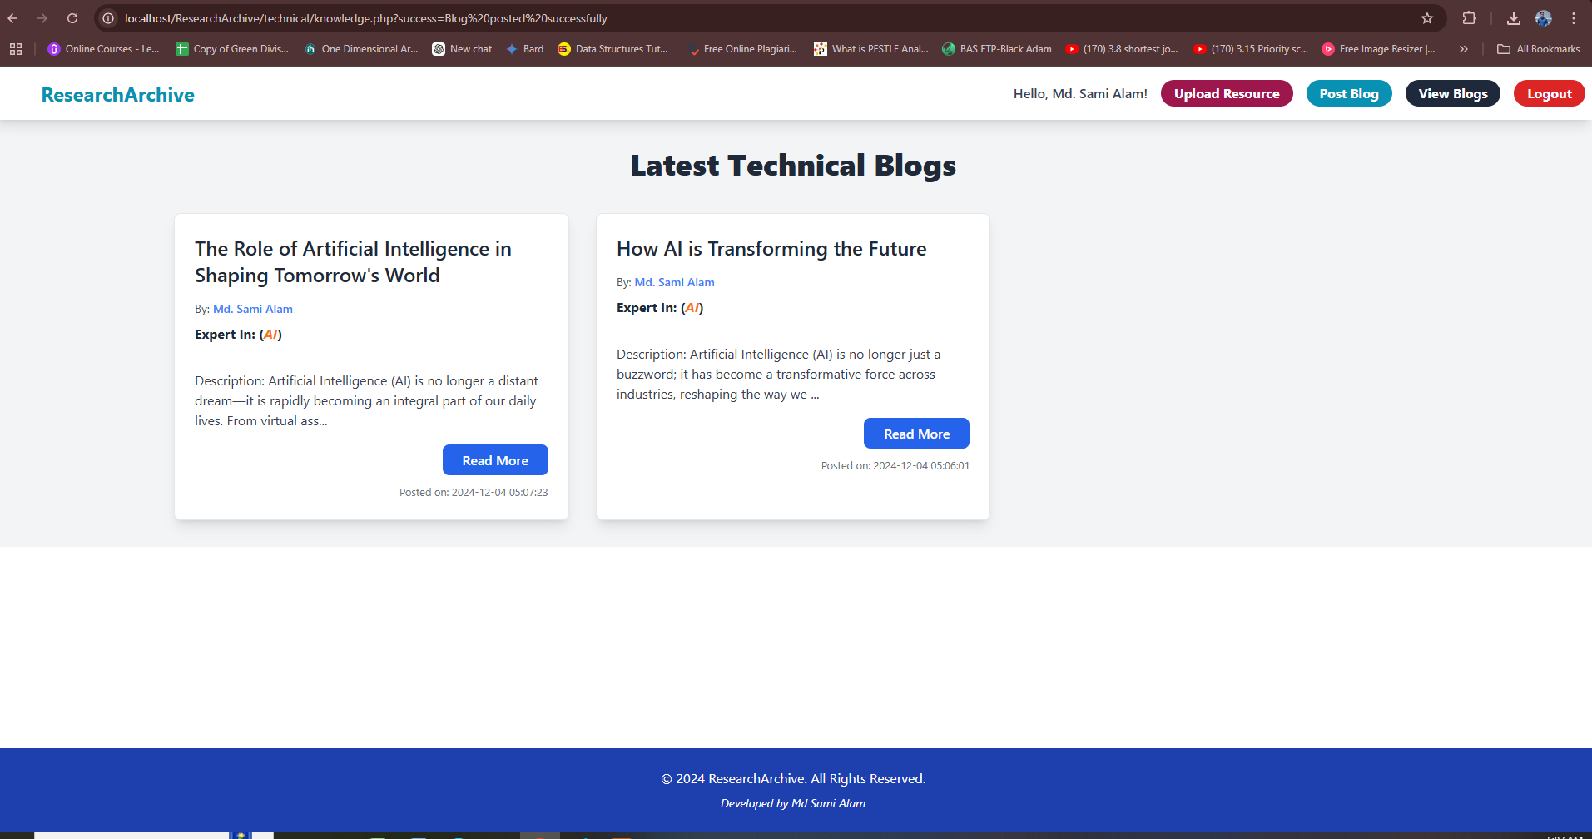

**If user want they can select read more then detail article:  
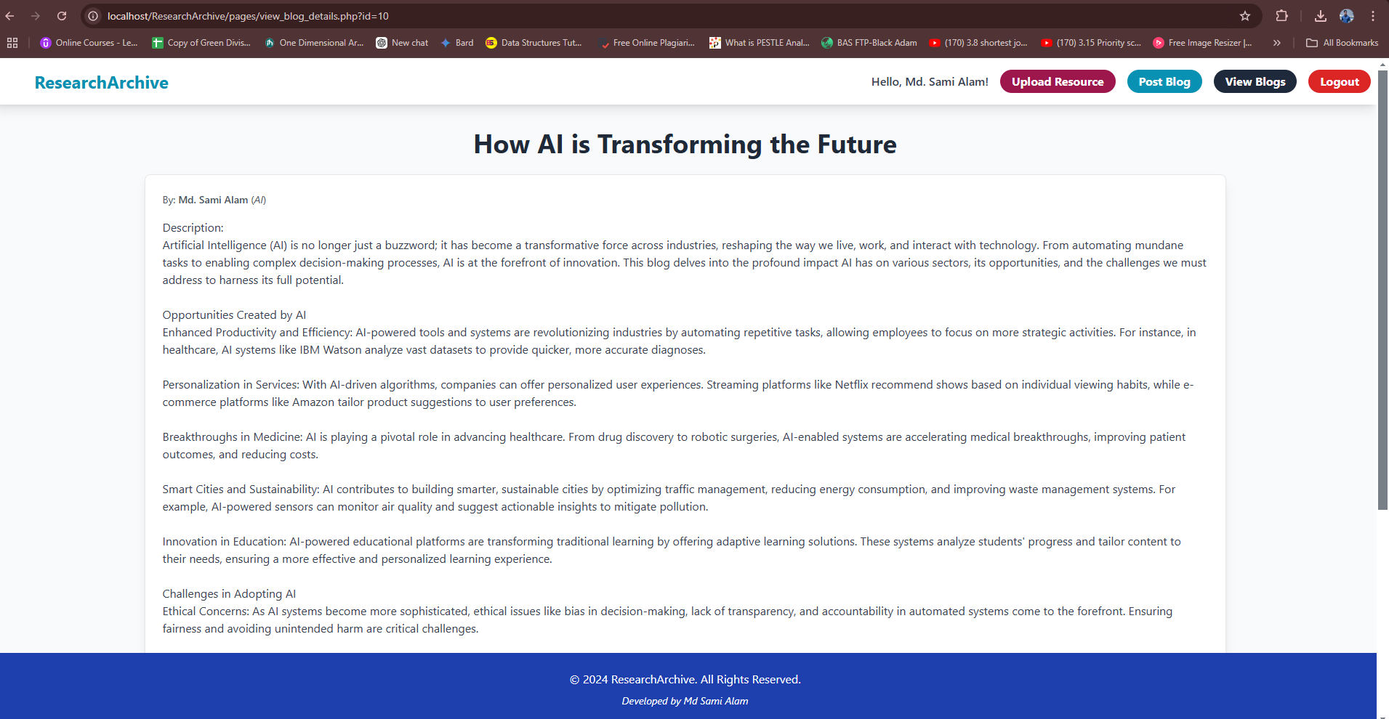**

**Thank You**